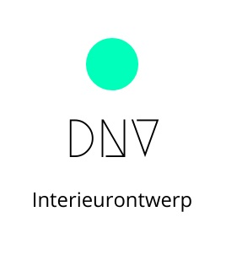Werkplanning – Keuzevak Interieurontwerp en -design BB

**Werkplanning**

|  |  |  |  |  |
| --- | --- | --- | --- | --- |
| Werkzaamheden | Uren | Werknemer | Startdatum | Einddatum |
|  |  |  |  |  |
|  |  |  |  |  |
|  |  |  |  |  |
|  |  |  |  |  |
|  |  |  |  |  |
|  |  |  |  |  |
|  |  |  |  |  |
|  |  |  |  |  |