**Ali's "Phantom Punch" Controversy Explained**

BY Melanie Albanesi   |   POSTED **05.24.2021**

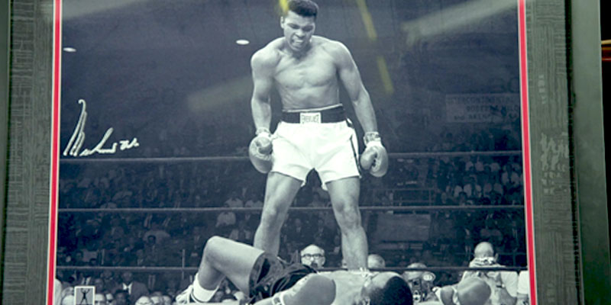

Gbenga Akinnagbe treasures this large reprint — autographed by Muhammad Ali himself — of the famous photograph from his match with Sonny Liston on May 25, 1965, when Ali knocked Liston out with a blow that no one present seemed to see. The first-round KO resulting from Al's so-called "phantom punch" is still hotly debated to this day. Kathleen Guzman appraised the signed print at $2,000-$3,000.

Onderkant formulier

Was it really a knockout? ... Learn more about Muhammad Ali's so-called "phantom punch" that put Sonny Liston on the mat.

DURING THE FALL OF 2020, ANTIQUES ROADSHOW visited Brooklyn, New York, to meet actor Gbenga Akinnagbe at his home and film a few of his favorite personal treasures. Among the items Gbenga shared with appraiser [Kathleen Guzman](https://www.pbs.org/wgbh/roadshow/appraisers/kathleen_guzman/) and our cameras was a photo of boxer Muhammad Ali taken during a match on May 25, 1965, in Lewiston, Maine.

The photo depicted Ali standing over his opponent, Sonny Liston, after delivering a final blow that knocked Liston to the ground. While valuing the photograph, appraiser Kathleen Guzman told Gbenga why this moment in sports history was so significant. “Ali knocked him out with a punch that no one could see. So now it’s the ‘Phantom Punch.’ And even today some people think this whole fight was rigged.”

Indeed, Ali’s punch happened so quickly and so early in the match, that most fans believed the knockout to have been fake. But why would a match between two of the greatest boxers of the time be staged? For over 50 years, fans and boxing experts alike have weighed in on this moment in history, and to this day, no one can agree on what really happened.

**The Build-up**

The 1965 match between Muhammad Ali and Sonny Lipton that produced the “Phantom Punch” controversy was not the first fight between the pair. On February 25, 1964, in Miami, Florida, the then 22-year-old Cassius Clay dethroned Liston as the reigning world heavyweight boxing champion in a seventh-round technical knockout. The fight was the boxer’s last under the name Cassius Clay, as he converted to Islam the day after and adopted the name Muhammad Ali. Ali’s connection to Malcolm X and the Nation of Islam had already caused a controversy in the news — Clay’s father claimed his son to be “brainwashed" — and the big fight was almost canceled.

The 1965 rematch between Muhammad Ali and Sonny Liston almost didn’t happen either. For one, Massachusetts was originally the only state willing to host the fight due to objections from The World Boxing Association, and second, Liston, whose career was heavily managed by the mafia, was repeatedly having issues with the law.

In May 2021, ROADSHOW spoke again to Kathleen Guzman, who explained further: “The fight was held in a high school gym in a little town in Maine because of problems with the Massachusetts boxing commission regarding organized crime connections with the Liston camp.” Lastly, Malcolm X had just been assassinated several days prior, on February 21, 1965, and Ali was thought to have a target on his back for his association with him.

**A "Phantom Punch"?**

When some 2,400 spectators entered the small arena in the town of Lewiston, Maine, they expected a hard-fought rematch between boxing’s youngest star, Ali, and Liston, who was the formidable favorite. However, what they got instead was confusion and outrage when Ali knocked Liston to the ground just a minute and 44 seconds into the first round with a punch that no one appeared to have seen.

Fans and boxing experts immediately questioned the validity of the punch — arguing that Liston was no easy target. Additionally, quick counterpunches such as the one that took Liston down were not a major part of Ali’s repertoire. “This was a hugely controversial bout because Ali was not known as a power puncher,” Guzman explained, “It’s not even completely clear that he landed anything when he dropped Liston in the first round.” Sportswriter Jimmy Cannon, who was ringside at the match, stated, “I saw that punch and it couldn’t have crushed a grape.”

So, was the match staged after all? Some believed Liston took the fall to rig the fight in Ali’s favor so the mafia could earn a profit in a bet against him. Others speculated that Liston threw the fight on purpose because he was afraid that Ali’s ties with the Black Muslims would put a target on his back if he beat Ali. Boxing historian Nigel Collins cited in his book, *Boxing Babylon*, that “The answer is fear. During training, [Liston] had been visited by a couple of tough guys claiming to be representing the Black Muslims. Their message was brutally simple: if Liston regained the title there would be a bullet waiting for him."

Amidst the hype and controversy, there are others who believe Ali simply landed a perfect blow and knocked Liston out, fair and square. But even after several decades of back and forth, no one can say for sure what truly happened.

Back in Brooklyn, Kathleen Guzman took a closer look at Gbenga’s photograph. While the photograph itself was a large reprint rather than an original, Muhammad Ali’s signature on the front was in fact authentic. All things considered, Guzman gave Gbenga's copy of the historic photograph a value of $2,000 to $3,000.