|  |  |
| --- | --- |
|  |  |

**Safe slime**

# Abstract

**Keywords**

* Chemical mixtures
* Physical properties
* Substances and health
* Calculations and Estimations

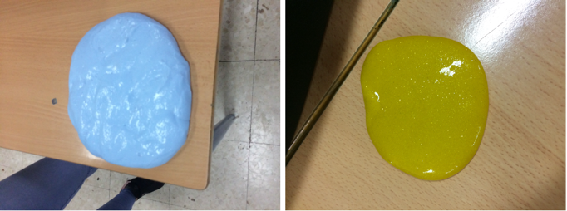SLIME is popular amongst kids and adults because of its texture and the possibilities to manipulate it in a playful way providing a unique sensory experience. There are plenty of recipes for making homemade slime but not all them are equally good, since some contain borax that can cause skin, eye or respiratory irritation and other health problems.

This activity challenges students to investigate the possible ingredients and the best procedure to make a safe slime. They will have to meet the challenge in groups, discussing alternative strategies, describing observations and searching for explanations.

# Lesson implementation

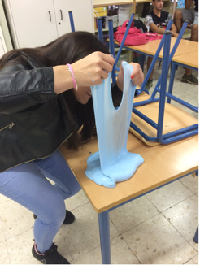*Introduction:* News about the risk of making homemade slime:

<https://www.ctvnews.ca/health/why-homemade-slime-could-be-dangerous-for-kids-1.3359013>

*Activities for students:*

* Classroom discussion on the dangers of homemade slime for kids.
* Investigate the best ingredients and procedures to make a safe slime.
* Make your safe slime. Write down your recipe, procedure and findings.
* 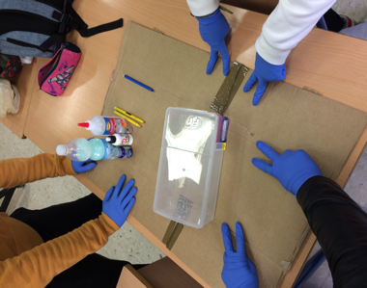Calculate the costs of your slime and compare this to store-bought products.
* Presentation and judgment: Present your slime in a poster-presentation. Judge each other’s slime on safety, costs and the quality of its texture.

|  |  |
| --- | --- |
| Copyright | Afbeeldingsresultaat voor creative commons share alike  Credits: Marta Romero Ariza, Ana María Abril Gallego, Antonio Quesada Armenteros.  Acknowledgment: We thank Juan Antonio Reyes Delgado and students from IES ALJANADIC for this inspiring classroom activity. |