Trains

Figure 1: double deck train
(source:www.ns.nl)
  - The length of one wagon is 30 meters. How long is a train of 6 wagons?

  - We don’t know the length of a double-decker wagon, so we call the length w.
A normal double-decker has 6 wagons.
What is the formula for the length of a normal double-decker?
Length =

  - Two extra wagons have been added. What is the new formula?
Length =

  - The maximum number of extra wagons is 6. What is the formula for the maximum length of a double-decker train?
Lengte =

  - A double-decker of 12 wagons has a length of 320 meters. What is the length of one wagon?

Necklace of beads
Jessica made a necklace of beads.

- How many big beads did Jessica use? And how many small beads?

- There is a smart way to count the beads: first count the beads of the basic-pattern, then count the number of basic patterns.
A basic-pattern is a small piece of the necklace, which is repeated several times. Draw the basic-pattern of Jessica’s necklace.

- The length of a small bead is called s and the length of a big bead b.
What is the formula for the length of Jessica’s necklace?
Length necklace = × b + × s

Jessica made a bracelet too:

- Draw the basic-pattern of the bracelet.
- What is the formula of the basic-pattern?
Length basic-pattern =

- What is the formula of the length of the bracelet?
Length bracelet =

- How many small beads did she use for the necklace and bracelet together?
And how many big beads?

- What is the formula for the length of the bracelet and necklace together?

Total length =

- Draw your own necklace and give the formula.
Use a basic-pattern.

The small bead is 2 mm and the big one is 6 mm.

- How long is Jessica’s necklace?

- How long is her bracelet?

- How long is your own necklace?

2 Adding and Subtracting letters
- With the necklace and bracelet you learnt how to add formulas.
Here are the formulas again, fill in the number of beads Jessica used:
Length necklace = × b + × s
Length bracelet = × b + × s
Total length = × b + × s
+
Do you remember how you learnt to multiply two numbers?

5 × 3 = 3 + 3 + 3 + 3 + 3 = 15

With letters it is the same:

5 × a = a + a + a + a + a = 5a
5 × −a = −a + −a + −a + −a + −a = −5a

Adding and subtracting two products:

5a + 3a = 5 × a + 3 × a = a + a + a + a + a + a + a + a = 8a

5a − 3a = 5 × a − 3 × a = a + a + a + a + a − (a + a + a)
= a + a + a + a + a − a − a − a = 2a

5a + 4b − 3a = a + a + a + a + a + b + b + b + b − a − a − a = 2a + 4b

Watch out, parenthesis (,) first!
3 × (a + 3a) = 3 × (4a) = 12a

- Write shorter:

a + a + a + a p + p + p − p − p − p − p

x + x + x + y + y + y r + r

- Write as sum:
3x =
3 y − 4x =

Using both the letter x and the multiply sign ×, could be confusing.
That’s why we use • for multiplying from now on.
5•a = 5a
- Calculate; write down all the steps if you find it difficult.
(a − 4a) • 3 b + 3a − 5b
2d + 6c − 2c − d 2t − 4t + 2r
More parentheses:
You know:
3 (2 + 4) = 3 • 6 = 18

but, you can use another order as well:
3 (2 + 4) = (3 • 2 + 3 • 4) (Put the 3 between the parentheses by multiplying both 2 and 4 by 3 → 3 • 2 and 3 • 4)
= ( 6 + 12 ) = 18 (Calculate the products and add them)

It’s the same with letters:

3 (a + 2b) = (3 • a + 3 • 2b) (Put the 3 between the parentheses by multiplying both a and b by 3 → 3 • a and 3 • b)
= (3a + 6b) = 3a + 6b (Calculate the products and add them)

- Write without parentheses:
2 (x – 3y) 5 (2x + 3y)
4 (2a – 3a) − (6x + 5y)
Hint: this is the same as: −1 (6x+5)

Puzzle!

On this page you see some expressions (an expression is a sentence of numbers and letters without an =-sign).

Connect the expressions that are the same. Sometimes there are more than 2 expressions the same, then you have to make a long string.

4 Multiplying letters

Opp = 2 • 3 = 6
2
3

Remember?

- Calculate the areas of the rectangles below, or write down which sides you have to multiply to get the area:

Opp =
…

Opp = …
3
4
a
3

Opp =
…

Opp = …

Opp =
…

Opp = …
3
4
a
a

Opp =
…

Opp = …

Opp =
…

Opp = …
3
4
a
b

Opp =
…

Opp = …

Do you remember the square numbers?

5 • 5 = 5² = 25

It is the same with letters:

a • a = a²

Multiplying different letters goes like this:

2 • 3 • 4 = 2 • 12 = 24 of 6 • 4 =24 of 2 • 4 • 3 = 8 • 3 = 24

2 • a • b = 2 • ab = 2ab

2b • 4a = 2 • b • 4 • a (write with points)
= 2 • 4 • b • a (put the numbers at the front and letters at the back)
= 8 • ab (multiply the numbers and put the letters in
alphabetic order)
= 8ab (remove the points)

- Write the areas of the rectangles of problem a as short as you can.

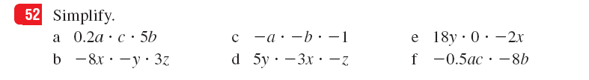

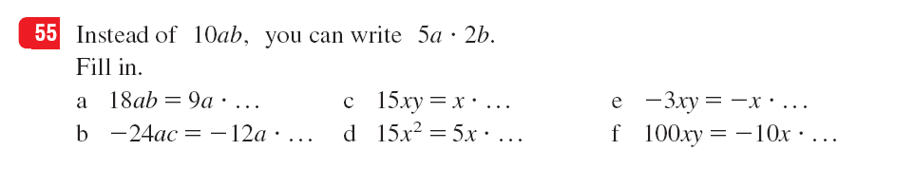

5 Like Terms
We saw that: 3a + 5a = 8a
We call 3a and 5a terms and because they have the same letter, they are like terms.
When you have to simplify (write as short as possible) you have to put all the like terms together
This means that each letter occurs only one time in your answer.

Like this:

3a + 4b + 5a + 2b = 3a + 5a + 4b + 2b
= 8a + 6b

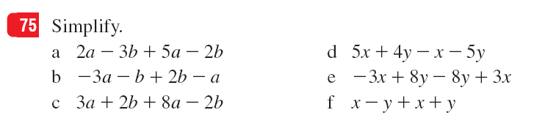

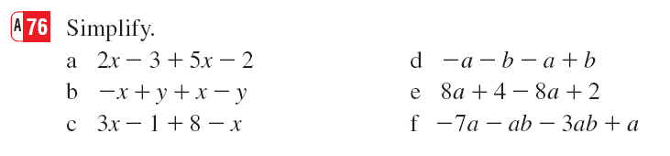

6 Puzzle!

Summary

All the rules together:

3a + 5a = a + a + a + a + a + a + a + a
= 8a

3a – 5a = a + a + a + −a + −a + −a + −a + −a
= −2a

3a • 5a = 3 • a • 5 • a
= 3 • 5 • a • a
= 15 • a²
= 15a²

3b • 5a = 3 • b • 5 • a
= 3 • 5 • b • a
= 15 • ab
= 15ab

3a + 2b − 6a + b = 3a − 6a + 2b − 1b
= −3a + 1b
= −3a + b

3a • 2b + 3c − 5a • b = 3 • a • 2 • b + 3c − 5 • a • b
= 3 • 2 • a • b + 3c − 5 • ab
= 6 • ab + 3c − 5 • ab
= 6ab + 3c − 5ab
= 6ab − 5ab + 3c
= 1ab + 3c
= ab + 3c

Remember the order of calculation!
- First everything between parentheses (,)
- Then squares ²
- Then multiplying and dividing • and : /
- Then adding and subtracting + and −

Translations

necklace = halsketting
basic pattern = basis patron
to repeat = herhalen
bracelet = armband
to add = optellen (of toevoegen)
to subtract = aftrekken
parenthesis = haakjes (,)

