**Going Out – Holidays & Festivals Reading**

**Task 8A**

Before reading, do this task. Match the words with the definitions.

1. a firework
2. the Houses of Parliament
3. a bonfire
4. a barrel
5. a penny
6. gunpowder

|  |  |
| --- | --- |
| **answer** | **description** |
| B | the main government buildings in the UK |
|  | a type of explosive material |
|  | a large wooden container |
|  | a large fire in the open air |
|  | a rocket that explodes in the sky, making bright light |
|  | a small coin in the UK |

**Task 8B**: Now you are going to skim the text: read the headline and sub headlines and study the photo. What do you expect the text to be about?

*I think this text is about*

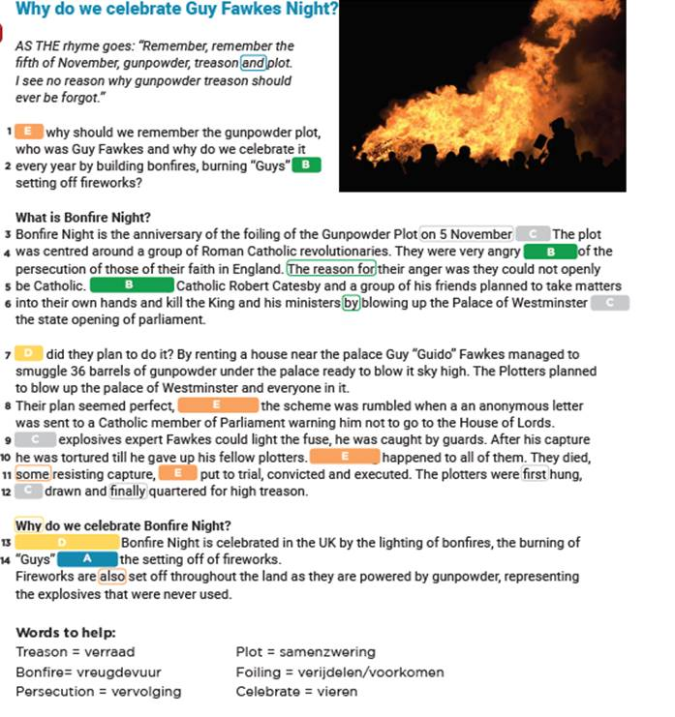

As you can see there are gaps in the text, which makes it harder to understand the text. The missing words are all signal words, remember them? Check out task 6 of Going out – Cinema to refresh your memory.

**Task 8C**: read the text again and find the right signal word for each gap in the text:

|  |  |  |
| --- | --- | --- |
|  | Category | Signal words |
| A | Description | alongside, and |
| B | Cause & effect | so that is why, the reason for, because of |
| C | Sequence | during, next, 1605, before |
| D | Question & Answer | we can conclude, how |
| E | Compare & Contrast | But, same thing, others, unfortunately |



**Task 8D: Now answer the rest of the questions about the text:**

Wanneer wordt Guy Fawkes’ Day gevierd? (alinea 1)

1. Alleen vroeger, in 1605
2. Elk jaar op 5 november
3. Met oud en nieuw

Wat wordt er gevierd bij bonfire night? (alinea 3)

1. Een katholieke feestdag gewijd aan de heilige Guy Fawkes
2. De start van het nieuwe jaar in het Parlement
3. Het voorkomen van een terroristische aanslag

Wat waren de mannen van plan om te doen met houses of Parliament? (alinea 4) ………………………………………………………………………………………………………………………………………………………………………………………………………………………………………………………………………………………………………………………………………

Waarom wordt er vuurwerk afgeschoten tijdens Guy Fawkes’ Day?

1. Om eer te bewijzen aan Guy Fawkes
2. Om te vieren dat houses of Parliament er nog zijn
3. Omdat de Engelsen gek zijn op vuurwerk.

