Escape the Classroom - Biology

## Teacher guide

Authors: Anne​ ​de​ ​Groot,​ ​Joris​ ​Koot​ ​and​ ​Tycho​ ​Malmberg ( <http://escapetheclassroom.nl/> )

### Goal of Escape the Classroom

The puzzles in this activity involve several biological theme’s and require students to use their biological knowledge and skills to escape the classroom or open a safe. Escape rooms can be used as a starter, or as a diagnostic check. In some cases the students might be introduced to subjects that will be important later on in the schoolyear. Furthermore, the students are expected to apply and experience some skills that are relevant in studying biology and science.

### Preparing the Escape the Classroom

Below, you will find a quick to do list on how to prepare the escape room. An instruction video (in Dutch) is available: <https://www.youtube.com/watch?v=qLtwt9cVWAI> . Each puzzle has a plan which students are supposed to follow (step by step explained).

Preparation steps:

* Prepare approximately five spaces four five teams in your classroom, these will be the “escape rooms” (approx. 4/5 students per team, less students or more students? 🡪 different number of teams).
* Print the Puzzle PDF file for each team. IMPORTANT! You need these in color and make sure you print them one-sided. ( five teams? Five copies of the puzzles)
* Print the PDF “Finish Code” (only one copy)
* Construct the box (order online or prepare your own box with a lock)
* Carefully follow the instructions for each puzzle (at the end of this letter)
* Put a prize into the box. For Example: Candy, keychains, the students’ cell phones, a gift certificate for a real escape room, fun subject related items or other gimmicks.
* Supply each team with a calculator, some scrap paper for calculations and a pencil (or instruct the students to bring this themselves).
* Make sure that on every team table/escape room there are some biological objects, these will serve as distractions. For example: Torso, plants, skulls, magnifying glasses, anatomical models, stuffed animals.
* The Classroom should be equipped with a screen, internet and sound to show an introduction video in which the countdown timer is included. The challenge starts as soon as the timer is on the screen. The timer is set for forty minutes and will countdown to zero.

How to play?

* Divide the class in advance in (heterogeneous) teams. Ideal group size is 5-6 students. In smaller classes there will be less teams.
* The students are not allowed to bring anything into the “room”. No book, no cellphones, no pencil cases etc. Except for each team they are allowed to have: one calculator, one pencil and one piece of scrap paper.
* Decide for yourself if you want to give some extra instruction on basic classroom rules during the escape room (e.g. do not write on the materials, breaking stuff etc.).
* Start​ ​the​ ​​introduction film <https://www.youtube.com/watch?v=0zZInWFuIj0> with the timer, and the students begin to play.

## Background

We have developed several puzzles. The puzzle with the turntables allows students to get acquainted with research skills. The students first read about research questions, results and have to draw a conclusion. When they have solved this puzzle, the students are rewarded with a UV light. This light is used by the pupils in the puzzle on the human body, in which they have to link organs to their correct function. In the 'what is it' puzzle, students have to apply recent knowledge and some general knowledge to solve the puzzle, then use the solution of this puzzle to select the correct travel report. Also for this puzzle the students need skills, they have to look for something in a text and link this to data from the table. The students are introduced to the different biological realms in this puzzle. In the last puzzle students have to discover with the red foil that they only need to use part of the drawing. If they have discovered this, they must study the drawing and determine which organism is presented in the drawing using the legend and the search card.

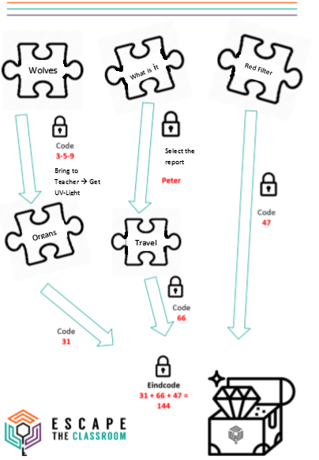Flow Chart:

**259**

### Wolves

Research/turntables:

* Paste the printed Wolf questions on a piece of cardboard.
* Apply the cardboard turning wheels in place with the split pens.
* The students must answer all questions correctly, in that case they will find the following:

|  |  |  |
| --- | --- | --- |
| Wheel | Correct Answer | Code |
| A | Research question | 3 |
| B | result | 5 |
| C | Wolves | 9 |

The students present this code to the teacher and receive a UV-light with which they should be able to solve the organs puzzle.

### What is it

* Print the puzzle ( to make it even more difficult you can choose to give the questions separately)
* Hint during the game: Cross out the right answers
* The next words will remain: Read Peter’s travel report

### Red Filter (Microscopy)

* Cut the red filter into 5 pieces, if necessary, take 5 loops or glue them on safety goggles.
* Hide the film / lens / glasses. E.g.: with tape under a seat or in a torso / model that is present on the team's table.
* Students must find the red foil and look at the cells, only the blue cells will remain visible.
* With the aid of the legend and the arrow diagram, the students will discover that the blue cells are fungal cells.
* Behind the fungal cells is the number 47, this is the third number that they need for the final code.

### Travel reports

* Print the reports and give each group a package report.
* The pupils have to choose the right travel report (that of Peter, this clue comes from the 'what is The game) (Read Peter's travel report).
* Now they have to look at which organisms can be found in the travel report, in Peter's report they will find: one animal (16 points), twice a plant (2 times 8 = 16) points), and once a fungus (34 points). This makes a total of 66 points and this Is the second number that they need for the final code.

### Organ functions

* Print the puzzle.
* Cut out the torsos from the 'mind map'.
* Use the UV marker (invisible ink) to write the red coloured figures at the torso (see picture below)
* Put the batteries in the UV lights and place the UV flashlights on your desk. Students who come from the wolves puzzle with the correct code (3-5-9) will receive a flashlight.
* The code is as follows 🡪 12 + 22-24 + 45 = 31

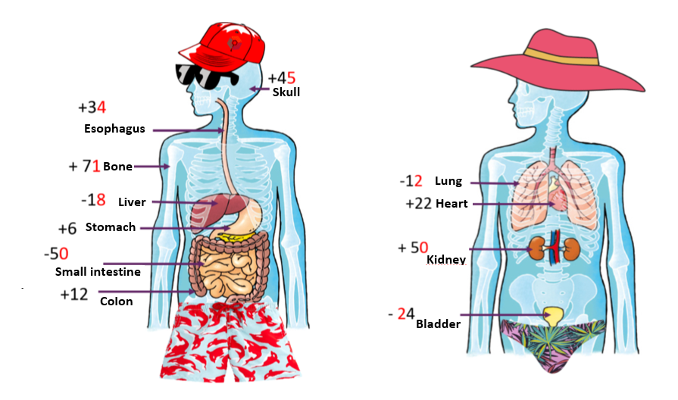

## Final code

* Put the wooden box (or other safe) in a central place in the room.
* Fill the wooden box with a price (for tips see above).
* Set the combination lock to 1-4-4.
* Print the document 'Final code' and place it next to the box.