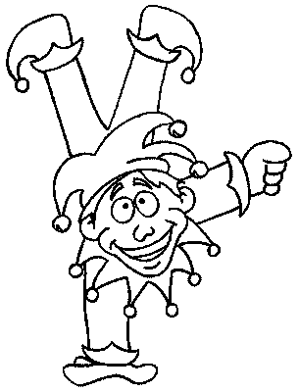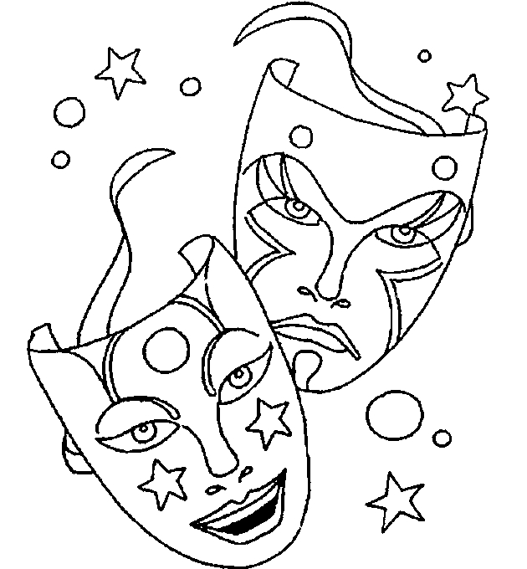Faschingsrätsel
Finde die Wörter waagerecht und senkrecht oder Diagonal!

K  - Koch  - Clown  - Prinzessin  - Fasching  - Pirat  - Geist  - Gespenst  - Luftballon  - Konfetti  - Maske  - Musik  - Karneval  - Zauberer  - Fee  - Hexe  - Tanz  - Pilz  - Tiger  - Katze  - Indianer  - Cowboy  - Löwe  - Prinz  - Narr  - Affe | Y | X | P | I | R | A | T | C | V | B | G | E | S | P | E | N | S | T
O | M | A | S | D | F | G | H | J | K | L | Ö | Ä | Ü | R | P | O | Z | U
C | L | O | W | N | Z | T | F | R | E | W | Q | W | E | I | R | T | A | U
H | I | O | P | Ü | A | S | A | D | I | N | D | I | A | N | E | R | U | F
G | H | A | F | F | E | J | S | F | G | H | J | K | L | Z | Ö | F | B | F
X | C | V | B | N | M | M | C | A | S | K | A | T | Z | E | S | D | E | G
C | O | W | B | O | Y | H | H | J | N | K | K | L | Ö | S | L | Ö | R | E
Ä | P | Ü | O | I | U | Z | I | T | A | R | G | E | I | S | T | E | E | Q
L | Ö | W | E | W | E | R | N | R | R | T | Z | U | I | I | O | P | R | Ü
U | A | S | D | F | G | H | G | J | R | K | P | R | I | N | Z | L | E | Ö
F | Ä | C | M | V | B | N | M | M | K | L | J | H | G | F | D | S | A | I
T | W | K | A | R | N | E | V | A | L | E | B | O | R | F | E | S | T | T
B | T | Z | S | U | I | O | P | Ü | Ä | Ö | L | K | J | H | G | T | D | I
A | A | Y | K | Y | K | X | S | C | V | S | T | E | Y | N | E | N | M | G
L | K | L | E | I | T | P | H | Ä | L | C | K | J | H | F | T | D | S | E
L | A | M | S | W | A | E | E | R | T | H | Z | U | N | O | Z | A | E | R
O | P | U | Ü | L | N | Ö | X | Ä | T | M | N | O | V | C | X | Y | N | S
N | M | R | 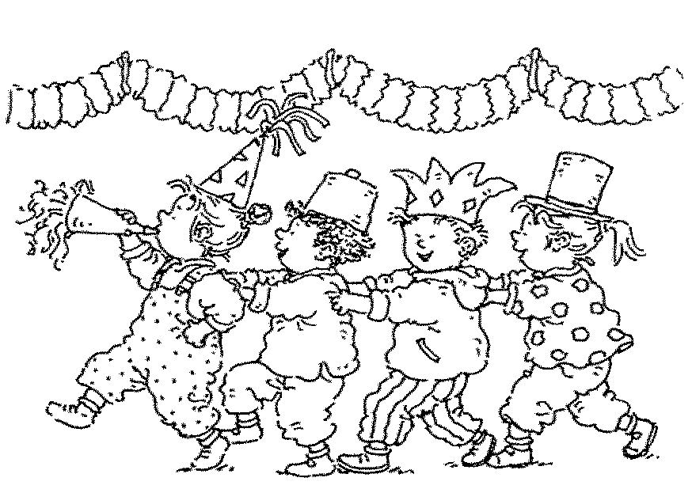F | G | Z | H | E | F | A | I | K | G | E | N | P | I | L | Z

