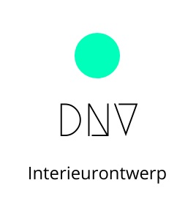Werkplanning – Keuzevak Interieurontwerp en -design BB – KB - MAVO

**Stappenplan**

|  |  |  |  |  |
| --- | --- | --- | --- | --- |
| **Werkomschrijving** | **Benodigd materiaal** | **Greedschap/machine** | **PBM** | **Werktijd** |
|  |  |  |  |  |
|  |  |  |  |  |
|  |  |  |  |  |
|  |  |  |  |  |
|  |  |  |  |  |
|  |  |  |  |  |
|  |  |  |  |  |
|  |  |  |  |  |
|  |  |  |  |  |
|  |  |  |  |  |
|  |  |  |  |  |
|  |  |  |  |  |
|  |  |  |  |  |