**International language of elements**

# Abstract

[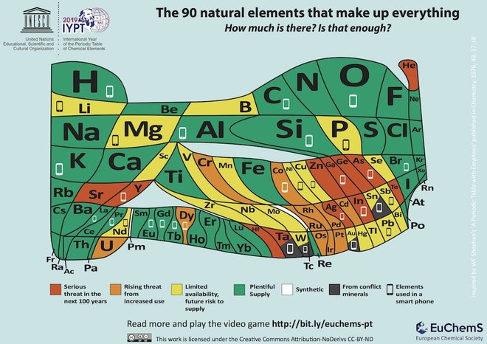](https://www.google.nl/url?sa=i&rct=j&q=&esrc=s&source=images&cd=&ved=2ahUKEwj6srK1u6zjAhWCzaQKHZP7CA0QjRx6BAgBEAU&url=https://www.livescience.com/64596-new-periodic-table-shows-helium-scarcity.html&psig=AOvVaw3OhZzYwimOCj-L9a00iM78&ust=1562920673975209)The periodic table is used by all science related subjects. Although it looks like a product of modern science, it has a very long, rich and multicultural history. Every day in students’ lives is influenced by topics related to the elements in the periodic table. Within this abundance of topics one finds several social scientific issues that are key to the 21st century such as: smartphone usage, plastic usage and recycling, pollution and pesticides.

In this activity students investigate the origin and background of several elements in the periodic table by combining history, science and sustainability. They explore the usage of the elements in everyday live and their availability. To wrap up they use this knowledge in order to critically examine something they use daily: smartphones.

# Lesson implementation

Introduce the periodic table of elements with the following link, a poster in your classroom or with the periodic table song.

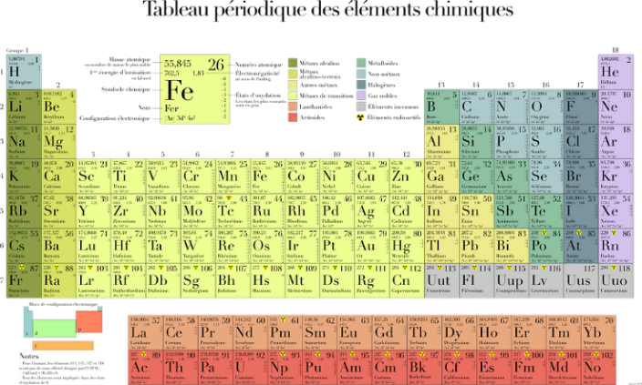<https://www.nature.com/immersive/d42859-019-00001-7/index.html?fbclid=IwAR2as8LqIVR-jItPIsm-44WpBZq8HuX-IDPZypV7lTr2Zcvd0ivTXw-CzYM&utm_campaign=coll-interactive_iypt&utm_content=paid&utm_medium=social&utm_source=facebook>

Let students name the elements they already know, this produces a list of known and “new” elements. Students can decide for themselves which elements they want to investigate.

Several examples of lesson activities on the elements in the periodic table are given below:

* Investigate several elements. Think of: place of discovery, mine locations, everyday usage, sparsity and related social and economic issues.
* Exchange your findings in a poster market.
* Make a version of the “element” song with your class/group using the elements you researched.
* Organise a student debate on sustainability and use of certain “conflict” elements.
* Divide the class into groups and investigate which elements are used in the production of smartphones. Let each group specialize on a certain element. Why is this element important in a smartphone? Are there enough resources? Is the element coming from a conflict area?
* 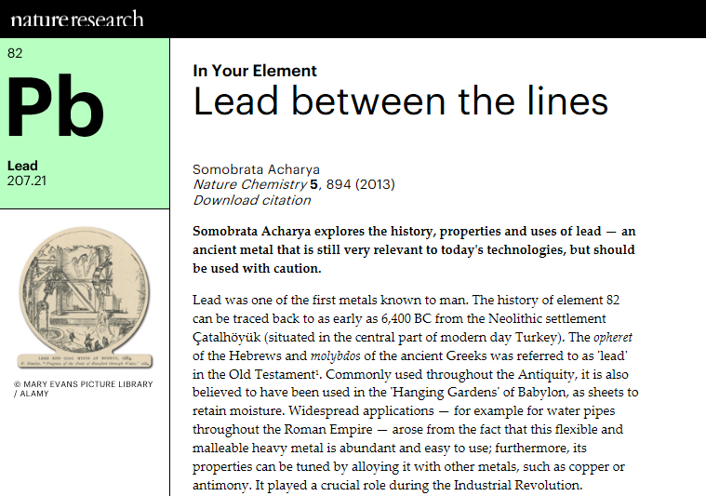After the investigation phase, divide the groups of experts onto other groups (mixed-element-groups) and exchange the information you found on all the elements.
* Think of a plan to make smartphones more sustainable. Which elements should we try to avoid, replace, re-use etc.
* Class discussion: how can you use this knowledge to improve sustainability in your own life?.

# Note from a teacher

This lesson activity was used by a teacher from Malta during the course. She considered the activity very useful in productively using the multicultural differences between students:

*“I can identify there are differences between students, but sometimes I see it as a challenge, while at other times I see it as an opportunity and try to incorporate it into the lesson. A very good example where this can be used is when doing the Periodic Table and naming the different elements. Students can choose an element which they know of and write its name on the board in their language, using the activity to identify the origin of the name of the element.. “*