**The Boy In The Box Case: Inside The Creepy Unsolved Mystery**

By Katie Serena | Checked By John Kuroski

Published **October 24, 2021**

Updated **November 16, 2021**

**Several theories have emerged, but the mystery of the boy in the box has remained unsolved for over 60 years.**

In the Ivy Hill Cemetery in Cedarbrook, Philadelphia, there sits a large plot, kept almost entirely covered in stuffed animals, donated by local families and visitors. The headstone reads “America’s Unknown Child,” a permanent reminder of the child who lies beneath it. He was found dead and alone in a box, and no one could identify him. The case of the boy in the box was one of Philadelphia’s [most baffling murder cases](https://allthatsinteresting.com/unsolved-murder-cases), stumping police for over 60 years, and still, today, leaving hundreds of unanswered questions.

In February 1957, a young muskrat hunter set out to check his traps, set near a park just north of Philadelphia. As he moved through the brush, he found a small cardboard box, lying discarded on the ground.

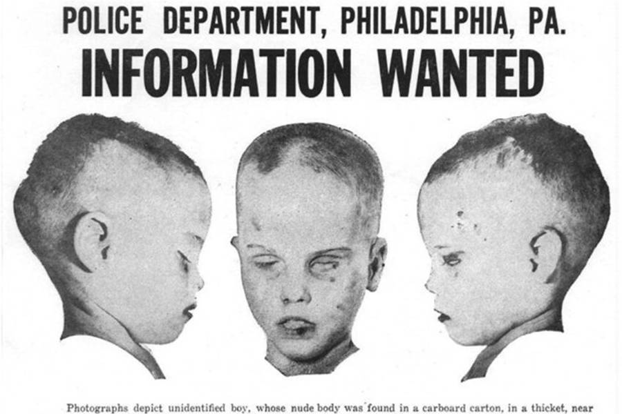

Wikimedia CommonsThe boy in the box, depicted on a flyer sent out to residents of surrounding towns.

Inside was the naked body of a boy, wrapped in a plaid blanket. Fearing that the police would confiscate his traps if he alerted them to the box, the young hunter ignored it, and resumed hunting.

Several days later, a college student driving down the road noticed a bunny running alongside the highway. The student knew there were traps in the area, and stopped to make sure the animal was safe. As he sifted through the underbrush searching for traps, he came across the box. Though he too feared interaction with the police, the student reported the body to them.

**Who Was The Boy In The Box?**

Given that the boy was young, between three and seven years old, police were hopeful that he would be quickly identified. However, once they saw the body, their hopes were dashed. While people would surely be looking for a missing boy who was healthy, well cared for, and clearly loved, it was unlikely that they would be looking for a scrawny, dirty, malnourished one. Unfortunately, the boy in the box was just that.

His hair was matted and seemed to have been recently cut as clumps of it still clung to his body. His body was severely malnourished and covered with surgical scars, most notably on his ankle, groin, and chin. Despite the fact that he looked abandoned, police fingerprinted him, hoping to find a match. Sadly, no one did.

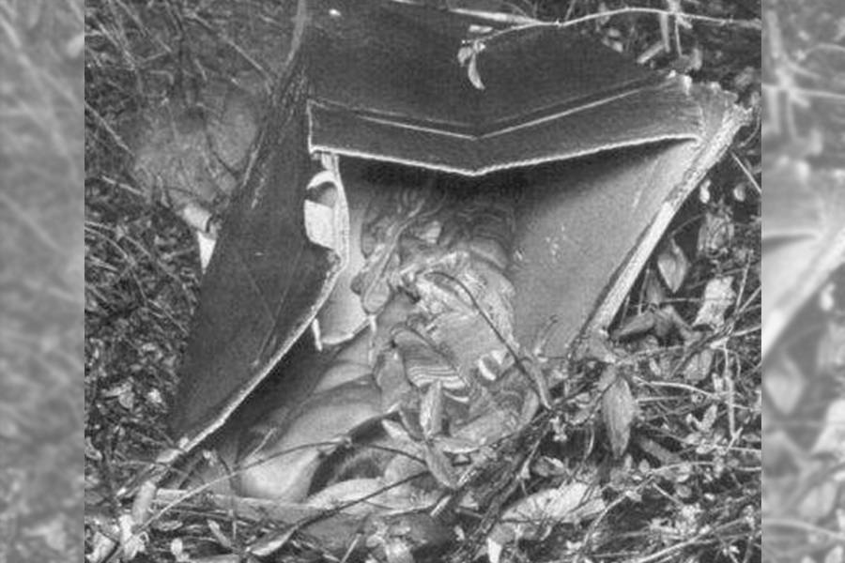

Wikimedia Commons-The crime scene where the boy in the box was found.

Over the next several years, [over 400,000 flyers were sent out](https://www.phillymag.com/articles/2006/05/15/who-is-the-boy-in-the-box-part-one/) to the Philadelphia area, as well as other towns in Pennsylvania. A forensic facial reconstruction was done, and a drawing of a happy young boy was included on all of the posters. Flyers were posted in police stations, post offices, and even included in the envelopes with gas bills, but still, no one came forward with information.

The crime scene itself was searched several times, but apart from several items of children’s clothing (all of which led nowhere), there were no leads. To this day, the boy’s identity remains as much a mystery as it was in 1957.

Though the case has run cold, the publicity and interest in the case by amateur investigators have turned up a couple notable theories throughout the years.

**Theory #1 About The Case**

In 1960, an employee of the medical examiner’s office was told by a psychic that the boy in the box had come from a local foster home. The police inquired about the boy at the foster home and found blankets similar to the one he had been wrapped in hanging on the clothesline, as well as a bassinet that was sold in the same box that the boy had been found in.

The employee theorized that the boy had been born to the daughter of the man who ran the foster home and that his death had been accidental. Despite the employee’s insistence of these facts, no connection was ever made between the boy in the box and the foster home.

It wasn’t until over 40 years later that another shocking theory emerged.

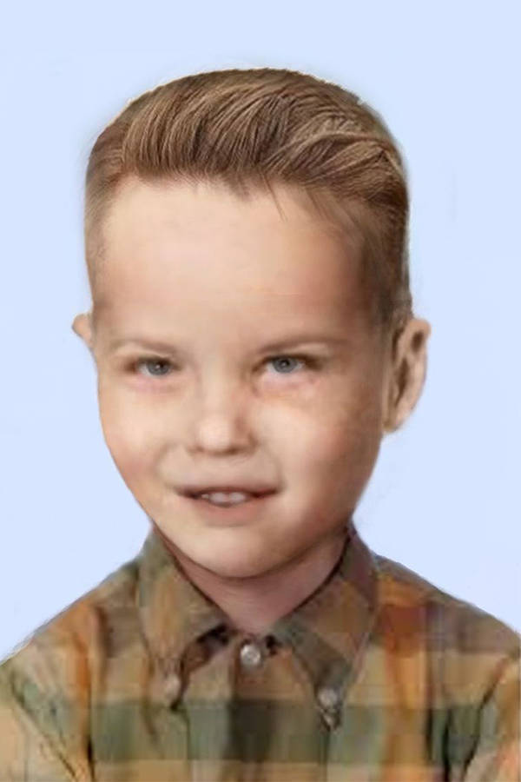

*Wikimedia Commons-A facial reconstruction of the boy in the box.*

**Theory #2 About The Boy In The Box Case**

A woman, referred to only as “M,” came forward, claiming that the boy had been purchased by her abusive mother, and abused for several years in her home. M claimed that after the boy vomited up his dinner of baked beans, her mother had bashed his head against the wall as punishment. Then, she’d attempted to bathe him, during which he had died.

The police initially followed this lead, as there were remains of baked beans in the boy’s stomach, and his fingers appeared to be water wrinkled. Those were both pieces of information that were never shared with the public. They were also encouraged by M’s description of the boy, as a small child with long hair. This fit with their theory that his hair had been recently chopped, as well as an old testimony from a man who claimed to have seen the boy being placed in the box near the woods.

Unfortunately, police eventually let the theory slide, as they were unable to verify M’s claims. After looking into M’s background, they found a history of severe mental illness. When they attempted to corroborate her claims with neighbors and friends, all of them denied ever seeing a child in the home. The theory was eventually dismissed as “ridiculous.”

Several other theories have been presented over the years, though all of them have eventually been discounted. It seems that the mystery of the boy in the box might never be solved, and that “America’s Unknown Child” could remain that way forever.