|  |  |
| --- | --- |
| Title | Dilemma cards |
| Subject(s) | Mathematics, Biology, Physics, Chemistry |
| Brief description | In this lesson we discuss the various dilemma’s on the given cards . For all dilemma’s curriculum, cultural or subject related the question is up for debate “Would you be able to discuss these topics in your classroom?” |
| Time | 5-30 minutes |
| IBL | The activity could be turned into IBL: Let the participants or students formulate dilemma’s they associate with, find suitable to their daily practise. |
| Achievement | - |
| Context | Several contexts, dilemma’s marked with are more related to topics that can be used in different contexts. |
| Culture | In different cultural and/or religious backgrounds some topics are not up for debate or discussable. Some topics/dilemma’s might touch boundaries that are respected differently across certain social/cultural groups. |
| Fundamental Values | Respect for different cultures and beliefs, discussing different moral and values. |
| SSI/RRI |  |

Lesson outline

Take a look at the posed dilemma’s:

You can use these cards in several ways in activities. Choose the way that best fits your group.

A few examples:

* Let the Participants discuss making the decision by “Head or Heart”
* Have participants choose the dilemma's they are most likely to encounter in their daily teaching practice, and discuss these in small groups.
* Create three areas (poster or table for example) in the room and label these: irrelevant, relevant, very relevant. Hand out 5 cards to each participant let them divide their cards amongst these areas. Present the distribution of cards to the group and discuss if anyone wants to change the position of a card and motivate that decision. Can they convince the group to agree on changing the placement of the card?
* Hand out or let the participant pick three dilemma's and let them describe how they would overcome these dilemma's in their classroom. In doing so have them share good practises from their own teaching.
* Ask participants to think of more dilemma's, for example ones that they did encounter in their daily practise? Add them to the list and discuss them briefly: do other participants have similar experiences

Dilemma’s

All dilemma’s begin with “*would you as a teacher ……”*



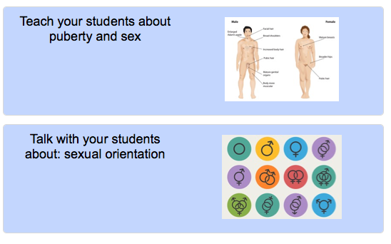

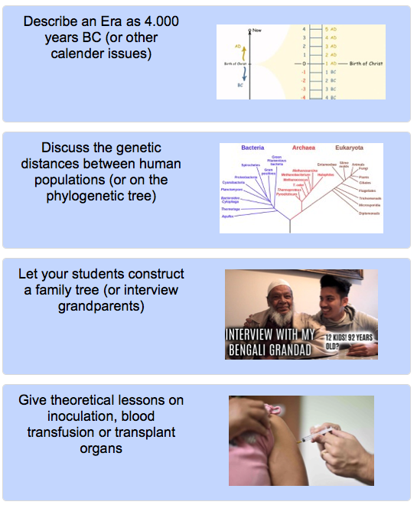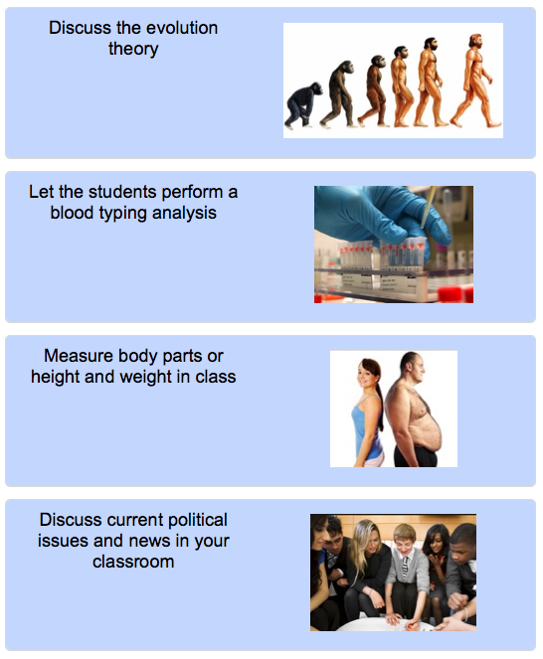

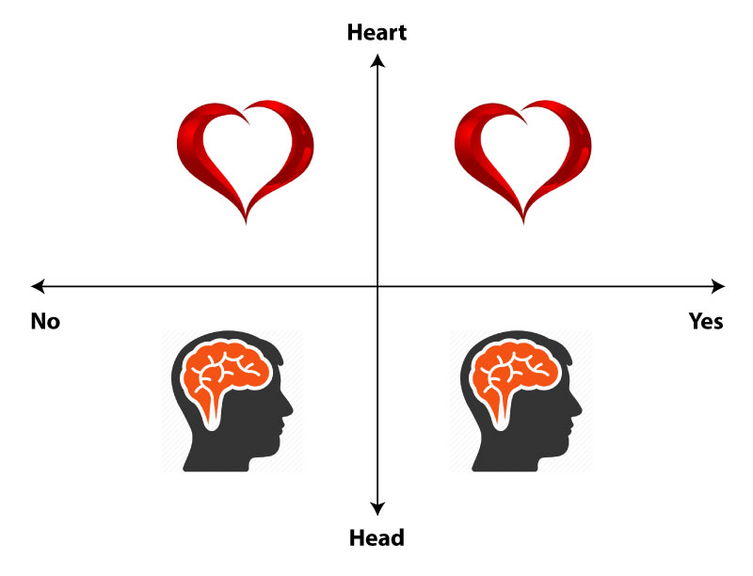Appendix: Head or Heart – Move reasoning

This activity combines reasoning with 'head' and 'heart' with physical movement ('move-reasoning') . Make sure there is enough room for participants to move along two axis (see figure on the right).

Select one of the dilemma cards and read it aloud. Ask participants to form their opinion and take position along the axis running from “Yes I would discuss or perform this in my class” to “No I would avoid this topic in my class”.

Next each participant considers whether his/her decision is based on feelings/beliefs (referred to as “heart”) or on rationality/thinking (referred to as “head”) and takes position in this direction as well. The head-heart axis is perpendicular to the yes-no axis. This will result in participants standing divided over the four quadrants.

Ask participants to explain why they took this particular position on each of the axes. Note: You may also ask them to explain their position immediately after they have chosen position on the yes-no axis. In that case you ask them first to explain why they took this position and then you ask them whether they reasoned more 'by head' or 'by heart' and you have them take their position according to the head-heart-axis. It is important to emphasize that all opinions are valid, meaningful and not up to debate. Be sure to ask participants on different positions to provide arguments: why did they take this position? Are there experiences in the past that formed their opinion? Is their opinion based more on beliefs/emotions or more on reasoning?

After some reasons/arguments haven been shared you may want to ask participants if they would rather move to another position now that they have heard more arguments . If participants have moved, ask some of them to explain what made them change their opinion. Was head or heart involved or both?