# C:\Users\ARABCOL USER\Downloads\WhatsApp Image 2021-02-15 at 00.17.47.jpeg

Quarterly Problem

*-Science Edition-*

How deep is the coin?

**→**

*Sometimes, things are not quite as they seem. And we even have a scientific experiment to prove it by “raising” a coin in a bowl of water – without touch.*

*You will need: 1 euro coin, a bowl, a cup of water, a ruler and a tape meter.*

Put the bowl on the table and the coin on the bottom of the bowl.

Stand upright and look at the coin.

Move away from the bowl until you are not able to see the coin.

Stay stand upright. (see Figure 1.)

Ask your friend to measure a, b, H1 and H2.

Ask your friened to add water to the bowl until you can see the entire coin.

Now ask your friend to measure the height of the water h as it apears in Figure 2.

Let your other friends do the experiment, then try to answer the questions below:

*Which of the parameters a, b, H1, H2 affect*

*the value of h? Try to answer the question*

*based on inquiry process.*

*Try to draw the light beam that enables you*

*to see the entire coin.*

**Brainstorm-Box**

Does the light travel in straight lines, always?

When you look at an object, does the light travel from the object to your eyes or vice versa?

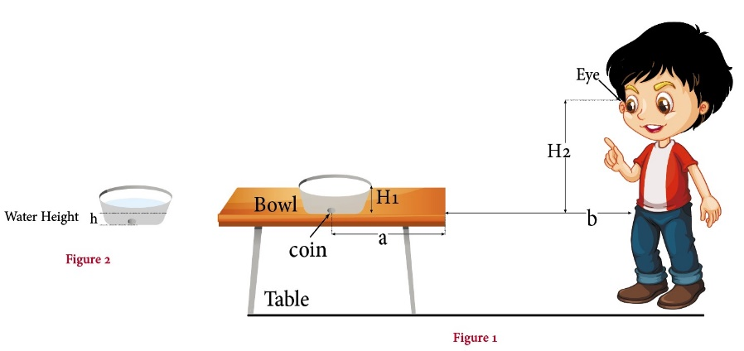

© Dr. Fadeel Joubran/International Centre for STEM Education (ICSE), 2021

CC-BY-NC-SA 4.0 License granted

Picture Source: Dr. Fadeel Joubran and Sharbel Elias

Whose method is the most accurate?

Be sure to state your approach clearly and understandably.

Also indicate what basis you used for your assumptions.