# Buch, Zurück Zur Schule, Lesen, Bücher

Quarterly Problem

*- Green Edition -*

Paper book or e-book reader?

Pixabay I Perfecto_Capucine

**→**

*"Just our children still read in paper books, my wife and I are always using e-book readers ".*

*I recently heard this statement from a friend (bookworm!). E-book readers have been around for quite some time, but it's only recently that they seem to be really catching on, thanks in part to offerings like "Onleihe" from public libraries and large tech retail platforms.*

This raises the question of the environmental impact of using a corresponding device compared to using traditional paper books.

The common approach to answer this question lies in life cycle analysis, also known as LCA (Life Cycle Assessment). Here, the raw material and energy consumption of a product or service is estimated over its entire life cycle. This can be quite tricky.

Let's try it anyway! Which is more resource-efficient? Reading printed books or using an e-book reader?

As a starting point, you can get a reader (if you have one) and a book. Look at them first: What are they made of and what is their mass? Write down your findings and begin your research.

Here are a few aspects that might be important:

- Greenhouse gas emissions

- Water consumption

- Land consumption (e.g. due to cultivation of raw materials)

- Useful life

**Brainstorm-Box**

The impact of largely replacing printed books with e-books goes beyond an LCA. What other impacts would it have?

TIP:

If you need help, check out our ["Life Cycle Assessment - How to Know" help sheet!](https://icse.eu/wp-content/uploads/2021/01/QP_Green-Edition_January-2021_Help-sheet_LCA-how-to-do-it.pdf)

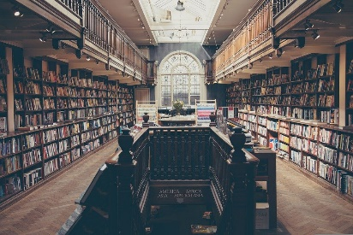



Whose method might be the most accurate?

Present your research in a concise, understandable manner.

Indicate what sources and assumptions you used for your estimates?

Pixybay I Foundry

© Dr. Peter Steurer/International Centre for STEM Education (ICSE), 2022

CC-BY-NC-SA 4.0 License granted

Picture Source: Pixabay.com/de

© International Centre for STEM Education (ICSE), 2022

CC-BY-NC-SA 4.0 Licence granted

Picture Source: Pixabay