It’s just a few more months until summer! Better start booking your holiday! But where should you go? **Create your own holiday brochure in which you describe your perfect holiday destination**! Write at least half a page, example below!

WELCOME TO TROPICAL EASTER ISLAND!

**EASTER ISLAND TROPICAL HOTEL & RESORT**

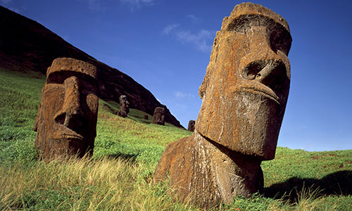

Enjoy our all-inclusive Easter Island hotel, located below the famous Easter Island statues!

Enter our fabulous hotel via the modern elevator and then enjoy our grand lobby where you can check in or maybe enjoy a drink at our bar. When you are all checked-in, proceed to our relaxation-station where you can get massages, soothing herbal baths or sweat it all out in our state-of-the-art saunas! IT’S INCREDIBLE!

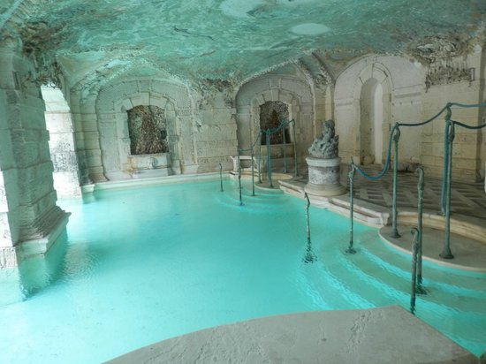Do you like to swim? Why not enjoy one of our 12 pools? Relax in our Emperor’s Pool or experience the thrills of our Tidal Pool! Feeling a bit more adventurous? Visit our very own sea cave! Climb rocks or slide down one of 20 waterslides. But look out for pirates!

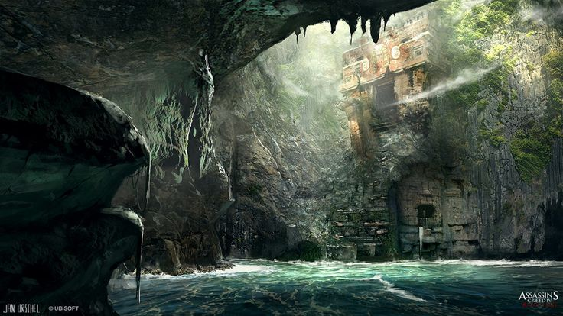

The Emperor’s Pool

The Sea Cave

***WARNING***

Make sure you are inside the hotel at 23:00. Some parts of the island will turn into Red Zones. Those not inside might be exposed to mutagenic radiation used to combat the variety of vermin currently infesting the island.

Perhaps you’d like to go out for a bit. Stretch your legs around the island and visit the world famous statues! Discover the ancient history of the statues (brought here by aliens, as we all know!) and enjoy the island’s nature.

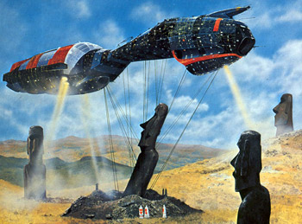

Book now on: [www.easter-island-vacation-of-a-lifetime.co.uk](http://www.easter-island-vacation-of-a-lifetime.co.uk)

Enter **EASTERISLANDHOTELANDRESORTAREINNOWAYRESPONSIBLEFORWHATEVERHAPPENSTOMEONTHEISLAND** for a cool 5% discount!

**We hope to see you soon!**