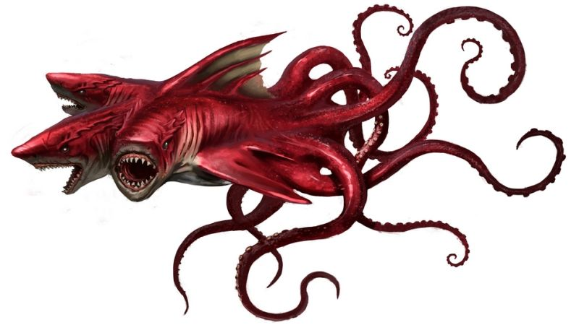The three headed sharktopus

The three headed sharktopus lives in the **deepest** regions of the ocean where it hunts and eats **large** octopi and **enormous** whales It captures its **unfortunate** prey with its **creepy** tentacles and then uses its **massive** teeth to rip the victim to **small** pieces.

The Three headed sharktopus’s **natural** enemy is the Piranhaconda: a **vicious** predator of both land and sea. The threeheaded shartopus and the Piranhaconda do not normally meet, because one lives on the **dry** land and the other lives in the **wet** sea. Sometimes a Piranhaconda is flushed down the **filfthy** toilet and will end up in the ocean where it will then meet the Sharktopus. A **fantastic** fight will then ensue, in which the **red** Sharktopus will try and drag the **green** Piranhaconda down to the oceanfloor. Altough the Piranhaconda can hold its breath for an hour, it will eventually drown.

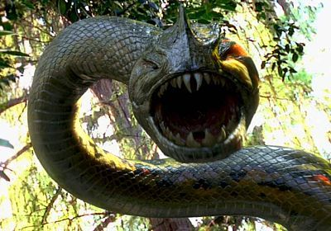

**Name**: three headed sharktopus. **Special info**: grabs with tentacles, bites with heads.

**Adjectives/adverbs**: strong, fast, quick, very dangerous.**Name explorer**:JeroenWintraecken

The three headed sharktopus reproduces by splitting in half, creating one two headed sharktopus and one one-headed sharktopus. The one-headed shark will then seek out delicious food and if it feeds enough, it will grow a second, and then a third head. The two headed shakrtopus will split again. Both sharks then go their own way.

Above: the Piranhaconda.

Top of page: Three headed Sharktopus

**Your assignment**

(RE: adjectives and adverbs)

*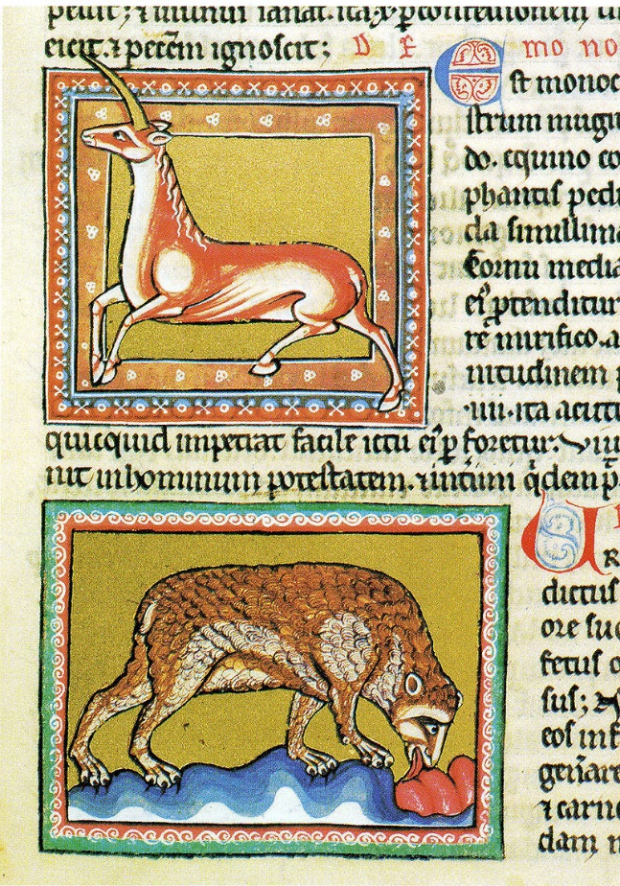A bestiary is a book filled with descriptions of monsters, strange creatures and plants. Made popular in the middle ages, these books described where the creature lived, what it looked like and what it did.*

*These bestiaries included animals people had never seen before (such as exotic birds from faraway countries), but also creatures that did not exist. These creatures were usually accompanied by a moral lesson (“if you don’t pray to God every night, this devil will come and eat you” or “if you eat your beans, a unicorn might visit you and you will have good luck”).*

*Unicorn and bear, Ashmole Bestiary, England,*

*early 13th century*

Create your own page of a bestiary. Describe a creature (imagined or real), where it lives, what it looks like and what it does.

Make sure it’s 1 page (no more, no less). Take my entry on the first page as an example (but do not simply copy!). Make sure you include this summary block:

**Name**:[name of your creature] **Special info**: [make up special stuff it does]

**Adjectives/adverbs**: [write adjectives or adverbs that are associated with your animal]

**Name explorer**: [write your name]

Email me your entry and I will combine them all into our own bestiary.