

Explained lesson series

English

Year 4

HAVO/VWO

# Introduction

Welcome to the Explained lesson series. In this reader, you will find the subjects and assignments you will discuss in the next few lessons. Each lesson is based on the popular Netflix series Explained or the subsequent The Mind, Explained. The series covers a wide range of topics and should include something interesting for everyone. We will cover the episodes on Memory, Monogamy, Cults, Astrology and Pandemics. Every lesson will include listening and watching, and the ‘after watching’ assignments will help you practice not only different English skills, but also skills you can use outside the classroom. The focus is mentioned before every lesson.

Every lesson is set up as follows:

* Watching the Explained episode in class
* Answering questions about the episode while watching
* Applying the information given in one of the assignments

Per lesson, there can be multiple assignments to choose from when covering a topic. In class, your choice will determine what you do and what skill you practice. There are some assignments that involve more advanced English. Ask your teacher for advice in case you’re unsure of what to do.

The completed writing assignments can be handed in for feedback and could serve as an opportunity to showcase your commitment and work ethic in class (eigenaarschap). The final lesson on Pandemics will include lessons which will be given at the end of this series. The goal of the lesson series is to practice different skills as well as expose you to different subject matter you might not be familiar with.

Have fun!

Dzenana

# Memory – lesson 1

Focus: practice writing a summary and covering main points in a text

Link to the episode: <https://www.youtube.com/watch?v=d95dOH-7GHM>

## While watching

Watch the episode and answer the following questions while watching:

1. What categories has the girl won in the memory competitions?
2. Fill in the blank: riding a bike is an example of … memory.
3. In what part is the ‘pang of stage fright’ saved?
4. What helps to increase memory?
5. What is the London cab test called?
6. True or false: our episodic memory is very flexible.

## After watching

Go to the following website: <https://www.vox.com/2019/9/12/20861728/the-mind-explained-netflix-vox>

Scroll down to the fold-sections at the bottom of the page. Fold open the *The Brain* section and choose one of the 5 linked articles. **Write a summary of the article in which you cover the main points of the texts.**

When you’re done summarizing, **compare your summary to someone in class who chose the same text**. Highlight the differences in your summaries (i.e. what you left out but the other person included).

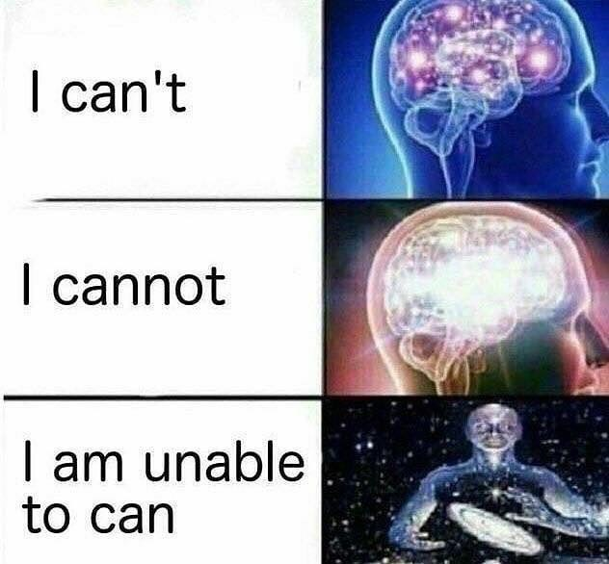

# Monogamy – part 1 of lesson 2

Focus: practice watching and listening

Link to the episode: <https://www.youtube.com/watch?v=DCGyLjBjuGI>

## While watching

Watch the episode and answer the following questions while watching:

1. What distinction is made between love and monogamy?
2. What is the reason for men being more inclined to seek multiple sexual partners?
3. What was the response given by one of the Indian’s to Jesuit’s question
4. True or false: in the animal world, true sexual monogamy is unheard of.
5. What was the main way to increase family labour force and peace treaties?
6. How were women and men described in Victorian gender roles? Fill in the blank: one of the things that makes human beings particularly interesting and maybe even unique in the animal world, is that …

# Cults – part 2 of lesson 2

Link to the episode: <https://www.youtube.com/watch?v=6NWIfiV1_XQ>

## While watching

Watch the episode and answer the following questions while watching:

1. What did the branding symbol represent?
2. What was Jonestown portrayed as?
3. What happened to the congress man who went to Guyana to investigate? *He died*
4. What are the characteristics of a cult?
5. What is the problem with the definition of a cult?
6. What country welcomed religion with open arms?
7. True or false: when manipulation becomes constructive, a group becomes a cult.
8. What are the 7 elements of indoctrination?



1. What 3 things can lead to a member leaving a cult?

# Astrology – lesson 3

Focus: researching and processing information, practice the ability to give a founded opinion

Watch the episode on Netflix (season 1 episode 7)

## While watching

Watch the episode and answer the following questions while watching:

1. Where did the idea of the zodiac originate?
2. Who was the first big astronomer?
3. What was his book called?
4. True or false: astrology and astronomy are separate fields.
5. What trend gave astrology a boost?
6. Fill in the blank: The Barnum effect suggests that …
7. What is the great appeal of astrology?

## After watching

For this part of the lesson, the focus is improving your writing skills. **Choose one** of the following assignments:

1. Sceptics – argumentative essay writing
2. Birth chart analysis – writing about your personal experience
3. Independent study – practice summarizing written texts

### 1. Sceptics

If you’re sceptical about astrology and the information discussed in the video, this assignment might be for you. You are going to write an argumentative essay on whether or not you believe in (some parts of) astrology and why. In your reasoning, you have to make clear what you base your opinion on and how it is different from other opinions. **In the essay, you discuss the matter in language that is formal, persuasive, convincing, but above all: respectful.**

This essay should be about 1 A4 in length minimum. In your essay, use at least one source and include it.

### 2. Birth chart analysis

Go to the following website: [www.justastrologythings.com/pages/chart/](http://www.justastrologythings.com/pages/chart/)

Insert your birth information necessary to compose a natal chart. **Copy a print screen** of your birth chart and read the different sections under heading 1. Planets in the Signs.

When you’re done reading, **write an analysis/report on whether or not you relate to the information in your birth chart**. Every planet should be covered in your analysis (so there will be a subheading for every planet) and the subheading should include one example of your personal experience of a situation in which it becomes apparent how you can/can’t relate.

This analysis should be about 1 A4 in length minimum. Include your birth chart in the analysis.

### 3. Independent study

If you’re interested in learning more about astrology in general, this assignment might be for you.

Go to the following website: <https://www.astro.com/astrology/in_intro_e.htm>

You will gather information on astrology to make it more comprehensible for yourself. This information will be compiled into one report in which you cover the following aspects:

* What do the planets represent
* What do the elements and their qualities represent
* What do the houses represent
* What do the major aspects represent

This report should be about 1 A4 in length minimum. If you reference any other websites to help your understanding, make sure to mention them as a source.

For more information on astrology, fun apps, personalized horoscopes and entertaining Instagram accounts:

* CoStar (app, website and Instagram @costarastrology)
* Café Astrology (website)
* The Pattern (app)
* Astro Future (app)
* Instagram accounts: @thatssoulastro, @inspire.zodiacs, @astrologyteens, @zodiac.secrets, @zodiac.signs, @glossy_zodiac

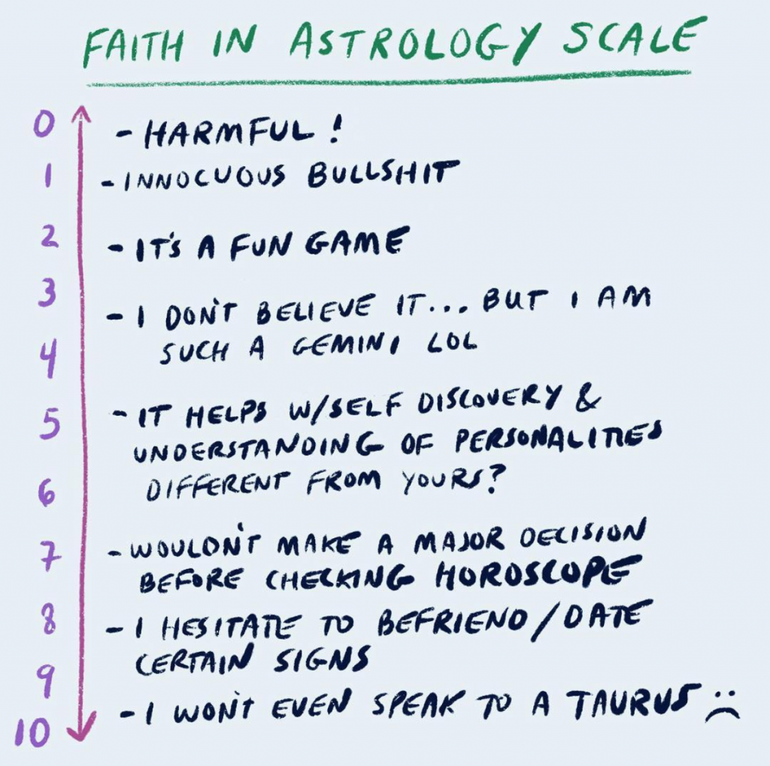

# Pandemic – lesson 4 and 5

Focus: researching and processing information, stimulating a critical attitude towards reliability of media sources

Watch the episode on Netflix.

## While watching

1. When was the first world-wide pandemic?
2. Fill in the blank: the woman in the video called Mother Nature the …
3. What is the mix of an animalistic and human virus called?
4. What made the H1N1 virus so dangerous/how did it work?
5. What made the virus spread quickly and effectively? Mention 2 factors.
6. What is believed to be the origin of the SARS virus?

## After watching

It is important to be well-informed so you can handle a situation accordingly. As they say, knowledge is power. But there are a number of factors that influence how information is conveyed and spread and these factors influence how the population reacts to a crisis and to each other. The way we’re presented information will influence what we believe to be true. Being aware of this influence can help you be critical about the information you consume and help you determine your viewpoint. The goal of this assignment is for you to gain awareness of the difference in media coverage depending on the timing and source.

**Choose one** of the following assignments. All of them involve looking up news articles concerning the following pandemic outbreaks:

* SARS
* Ebola
* Corona

You will work together in groups of 3 or 4. All members of the group will have chosen the same assignment. You will give a presentation (5-10 minutes) in which you discuss your findings. You can choose to cover all three pandemics in your presentation, or you can focus on 1 or 2. The presentations will be given in the next lesson.

### 1. The influence of time

Time can influence how we see a subject for a number of reasons. The passing of time not only makes more research and information available, but it also gives room to more opinions on the matter and more spreading of misinformation as events go on. To see the effects of time, you are going to find articles regarding the pandemic outbreak(s) from its earlier and later stages. **Compare and contrast (one of) the earliest publications/articles on the subject to (one of) the most recent.** You will use this information to prepare a short presentation with your group.

In your presentation you must discuss:

* How the publications/articles are similar/different (how elaborate is the writer, what is assumed to be ‘known’ already)
* What language is used (what tone of voice, mood, does it spark panic)
* What new information has surfaced between the first and more recent publication and how does it influence the publication/event

### 2. The influence of background

There is a difference in media coverage between sources due to the basic way the medium is set up. A newspaper has only one headline to draw your attention, Twitter articles use clickbait, whereas a news broadcast can count on your attention for much longer. You’re going to investigate how much influence the media source itself has on the coverage of the topic. To do this and see the influence, you’re going to find publications regarding the **same event** (pandemic development) **that was published on the same day from different sources. Compare and contrast how it is different and argue which is more reliable if there is a difference**. You can choose from different media sources i.e. multiple newspapers (comparing articles), multiple TV-programmes (comparing news broadcasts), social media apps and outlets (comparing public reactions/engagement), political commentary (responses from different countries) etc. You will give a short presentation in which you showcase your findings.

For more information on global health issues and the most accurate updates on the current situation:

* <https://www.who.int/>

