Havana Syndrome: 7 Bizarre Things We've Learned About the Mysterious Illness

BY

[Caroline Byrne](https://spyscape.com/article/havana-syndrome-7-bizarre-facts-about-the-mysterious-brain-illness)

Onderkant formulier

‍‍

It was late at night in Havana, Cuba in 2016 when one of the US embassy staff awoke to a loud, piercing sound in one ear, followed by acute nausea and vertigo. Within years, similar symptoms of the mysterious illness had been reported by hundreds - some say as many as 1,000 - US spies, diplomats, and defense officials in China,[Russia,](https://spyscape.com/article/moscow-syndrome-is-the-kremlin-targeting-the-cia-with-invisible-weapons) Austria, Serbia, the White House, and beyond.   
  
The US still doesn’t know who or what is behind the incidents. Theories range from a sonic weapon attack to nerve agents and microwave death rays. There’s no physical evidence of a weapon, however, and Moscow, China, and Havana deny any involvement in the attacks - if there were, in fact, any attacks to deny.

The CIA has tentatively ruled out that the mysterious symptoms known as Havana Syndrome are the result of a sustained global campaign by a hostile power. But, in dozens of cases, the agency hasn't ruled out foreign involvement - including in cases that originated at the US Embassy in Havana.  
  
So what *do* we know about the mysterious so-called Havana Syndrome?  
‍

**1. Energy attacks could be behind the symptoms**

Like a plot twist from a spy thriller, the US [National Academies](https://www.nationalacademies.org/news/2020/12/new-report-assesses-illnesses-among-us-government-personnel-and-their-families-at-overseas-embassies) found that the most plausible explanation is that the US is being attacked by directed, pulsed radio frequency energy - in other words, microwave attacks. The technology dates back to the US-Soviet Cold War when high-powered beams were designed to disable electronics. Electronics weren’t disrupted during the 2016-2017 Havana attacks, however, suggesting either that power levels were lower than required, or microwave-directed-energy weapons weren’t used. [*Foreign Policy*](https://foreignpolicy.com/2021/05/10/microwave-attacks-havana-syndrome-scientifically-implausible/) pointed out that only two of the National Academies’ 19 committee members seem to have any expertise in microwave technology - and it's not their specialty.   
‍

**2. There have been previous microwave attacks on US embassy staff**

[](https://spyscape.com/podcast/havana-syndrome-special)During the Cold War, beams of microwaves were aimed at the US Embassy building in Moscow from at least 1953 to 1976, according to [medical studies involving embassy staff](https://www.ncbi.nlm.nih.gov/pmc/articles/PMC3509929/). Initially, a beam bathed the 10-floor US Embassy, directed from an apartment building about 100 yards to the west.  
By 1975, there were two beams, one directed from about 100 yards east and the other south. The US determined espionage was the most likely motive, with beams used to activate embassy bugs or interfere with American transmissions. A shield was eventually installed and - at least officially - no adverse health effects were found.

**3. The US Embassy in Cuba isn’t the only incident**

What began with a dozen complaints in Havana in 2016 soon rose to hundreds of reports, including CIA staff in far-flung places. CIA officer Marc Polymeropoulos awoke in a Moscow hotel room with severe vertigo, unable to stand: "Of course I'm concerned about the adversaries behind this, because ultimately, I believe it's an act of war," [SPYEX consultant Marc Polymeropoulos](https://www.spyex.com/expert/marc-polymeropoulos) told [SPYSCAPE's *True Spies* podcast.](https://spyscape.com/podcast/havana-syndrome-special) Other CIA officers complain of attacks in London and Uzbekistan. Mystery ailments struck US soldiers in Syria. Canadian Embassy staff also complained of concussion-like symptoms while in Havana, with one [describing himself as a ‘zombie’](https://ottawacitizen.com/news/local-news/i-should-not-have-been-sent-back-there-canadian-diplomat-says-government-sent-him-back-to-cuba-with-brain-injury). Several incidents were reported in the US including a National Security Council staffer who described collapsing at the White House gates, convinced he was going to die.

[[](https://spyscape.com/podcast/havana-syndrome-special)](https://spyscape.com/podcast/havana-syndrome-special" \t "_blank)

‍

‍

**4. An incident in China mirrors the Havana situation**

[Catherine Werner](https://www.nbcnews.com/politics/national-security/mother-u-s-diplomat-hurt-health-attack-speaks-out-n938191) was jolted awake one night in 2017 by a pulsing, humming sound in her apartment in Guangzhou, China. She suffered headaches, nausea, and loss of balance for months, initially believing it was connected to high levels of pollution. Her mother flew out to help and also fell ill. Even Werner’s dogs were ill. Werner was medevaced back to the US and diagnosed with an ‘organic brain injury’. The State Department [tested about 300 other US staff](https://www.nbcnews.com/politics/national-security/mother-u-s-diplomat-hurt-health-attack-speaks-out-n938191) in China, sending 15 home for further tests. China denied any role in what the US termed a ‘health attack’. No cause or culprit has been identified.‍

**5. Canadian scientists have focused on possible chemical causes**[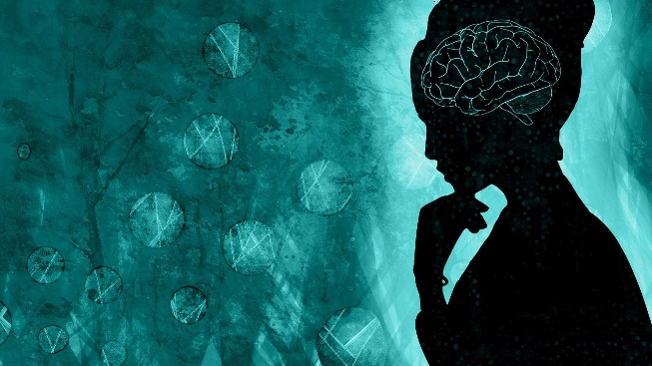](https://spyscape.com/podcast/havana-syndrome-special)Dozens of Canadian Embassy staff and their families also became ill in Havana, leading Canadian researchers to suggest [Havana Syndrome may be linked to chemicals](https://www.cbc.ca/news/canada/havana-syndrome-neurotoxin-enqu%C3%AAte-1.5288609) used in pesticides, insecticides, and nerve gases. Cuba launched an aggressive campaign against mosquitoes in 2016 to stop the Zika virus, spraying in and around offices and diplomatic residences. Separately, the US academies looked at chemical pollutants - along with other possible causes including an infectious disease - but decided the explanations didn’t add up.

‍

**6. Psychological problems may drive up the numbers**

Sufferers described the initial noise as screeching, chirping, clicking, and piercing followed by a sensation of intense pressure or vibration. The side effects are physical - loss of movement, hearing, and concentration - but Is Havana Syndrome also psychological? In a [2019 study](https://journals.sagepub.com/doi/10.1177/0141076819877553?url_ver=Z39.88-2003&rfr_id=ori%3Arid%3Acrossref.org&rfr_dat=cr_pub++0pubmed&), US-New Zealand psychologist Robert Bartholomew likened Havana Syndrome to war trauma: "A signature feature of shell shock was concussion-like symptoms." Other experts were less convinced, however, pointing out that the high number of complaints and vast geographic reach make the link to trauma or mass hysteria less likely.  
 **7. No one is certain who is behind the ‘attacks’**‍

The US hasn’t officially pointed the finger at any country but, if the incidents are related to microwave beams, there are plenty of suspects. The US, Russia, China, and dozens of other countries have [active, high-power microwave research programs](https://www.defenseone.com/ideas/2020/12/scientists-suggest-us-embassies-were-hit-high-power-microwaves-heres-how-weapons-work/170714/). So, there could be one country or a cabal of international villains operating in the shadows. On the flip side, there’s no evidence yet that secret microwave weapons - or any other weapons - are being used to target individuals. And without a smoking gun, Havana Syndrome will remain one of the most peculiar enigmas in espionage history.