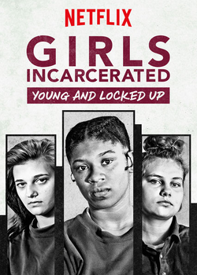**Girls incarcerated**

**Before watching – speaking**You’re going to watch an episode of Girls Incarcerated, an American documentary television that follows the teenage inmates of the Madison Juvenile Correctional Facility in Madison, Indiana. Before we start the video, talk about the questions on the Wikwijs.

**While watching**

1. John Galipeau says that Madison is unique because most girls aren’t sentenced to a certain amount of time. When can those girls leave?  
   _____________________________________________________________________
2. Brianna is getting written up for something.   
   a. What does that mean?  
   _____________________________________________________________________  
     
   b: What did she do?  
   _____________________________________________________________________.

c: Why is that not allowed?  
_____________________________________________________________________

1. What does getting a burgundy shirt mean?  
   _____________________________________________________________________  
   _____________________________________________________________________
2. How has Chrissy changed in the two years she’s been at Madison?  
   _____________________________________________________________________
3. What happens every Wednesday and how does it influence the girls?  
   _____________________________________________________________________
4. Why is education important according to Mr. Hawkings?  
   _____________________________________________________________________
5. What happens to some girls close to their release date? And what does John Galipeau think the reason is?

__________________________________________________________________________________________________________________________________________

1. What is M.A.C.?  
   _____________________________________________________________________
2. Why is Brianna’s family so important to her?*_____________________________________________________________________*

**Profiles**

Fill in the information about the girls. When you think the information isn’t given, you write down ‘n/a’.

**Brianna**

Age:

Crime(s):

Time spent at Madison:

Time left:

**Chrissy**  
Age:   
Crime(s):   
Time spent at Madison:   
Time left:

**Aubrey**

Age:

Crime(s):   
Time spent at Madison:

Time left:

**Heidi**

Age:

Crime(s):

Time spent at Madison:

Time left: