|  |  |
| --- | --- |
|  |  |

**Road safety**

# Abstract

In an article from 2006 based on findings by the Worlth Health Organization Heidi Worley states: “*Road traffic accidents—the leading cause of death by injury and the tenth-leading cause of all deaths globally—now make up a surprisingly significant portion of the worldwide burden of ill-health. An estimated 1.2 million people are killed in road crashes each year (…).”[1]* Road usage increases every year, making road safety one of the leading social scientific issues of the present and the future.

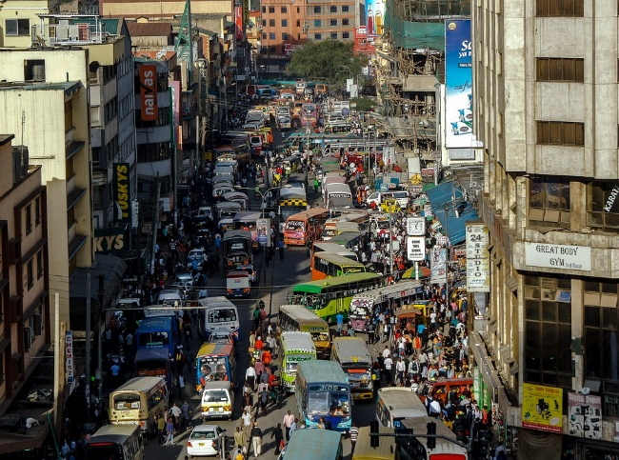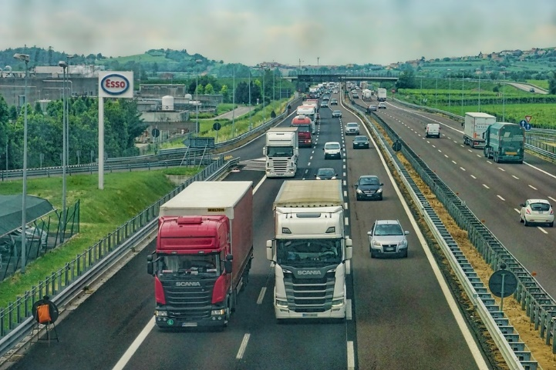Students are daily users of our roads, both passive and active. Therefore, investigation of road safety is both relevant and part of their citizenship development. The topic is multicultural because of the differences between road construction and usage between countries.

In this lesson activity the physics of car crashes are investigated using a self-built simulation and Newton’s laws. This knowledge on car crashes is then used to explore the issues around road safety with a social scientific and multicultural scale.

# Lesson implementation

Texts or videos about road safety and car crashes are provided as an appetizer at the start to get the students thinking about the topic.

Road safety can lead to numerous discussions and (practical) assignments. The examples below focus on the physics of car crashes and the related social and multicultural issues:

* Build a simulation of a car crash using the slope, the toy car, the road obstacle and the doll provided by the teacher.
* Make a plan for the execution and recording of the simulation.
* Execute your simulation and record your results. Can your results be explained by Newton’s laws? What are the limitations of your simulation?
* Class discussion: what are the key characteristics of a good simulation? How can results be explained by Newton’s laws? What are the limitations?
* How does the simulation you just built relate to road safety? Read: <https://www.prb.org/roadtrafficaccidentsincreasedramaticallyworldwide/>. And discuss with your group.
* Investigate laws for roads and road usage in different countries, such as road design, helmets, maximum speed, overtaking, airbags and seatbelts. Make an overview of the differences that are most likely to impact road safety.
* Choose one of the road safety factors from your overview to investigate further using Newton’s laws. Make a poster and share your findings with your class mates.
* Role-play debate: suppose part of your class is the governing body of a country trying to decide if a road’s maximum speed limit should be raised from 120 km/h to 130 km/h. The other half can take on roles as -for example- scientist, civilian and environmental activist. Debate the decision using arguments that are grounded and just.

1. <https://www.prb.org/roadtrafficaccidentsincreasedramaticallyworldwide/>