dier 1 1

English IBS: recreationpark (“recreatiepark”)

This English IBS has two parts: a product and an English Test

Product:

You are going to create a guide to a recreationpark.

1. Draw a map of your own recreationpark (a zoo or a petting zoo)
2. Create a folder to go with your map.

Your zoo/petting zoo has at least 2 different biomes (google this word!)

Your folder has to -at the very least- include the following:

* A description of the animal in the park (colour, size, number of legs etc)
* What the animal eats.
* What the animal needs to live happily.
* The different parts of the park (food, toilets for instance)

The folder has to have a minimum of 5 pages (see example!)

Styling (pictures, font & fontsize etc) is entirely up to you.

You present this information in an attractive format and hand it in with your teacher.

You have to hand this in, before you can do the test.

*Ask for feedback on your product during the English hours: your teacher is available to you then.*

*Please be advised: you have to hand in this product BEFORE the autumnbreak.*

English test:

English Test:

The test of Period 1 will be a reading test. There will be 3 lessons reserved for reading skills.

The first is obligatory. During this lesson, your teacher will explain what the reading test looks like and what you can do to practice.

The second and third are not obligatory. You have to tell your teacher that you are at school, but you can work on other things (for example your Dutch IBS or even other subjects).

*With this assignment you will be learning:  
-vocational vocabulary (words associated with the recreationpark and recreationpark-animals)*

*-learning about how to take care of a certain animal*

*-practising with giving information to others in a clear way.*

Example:

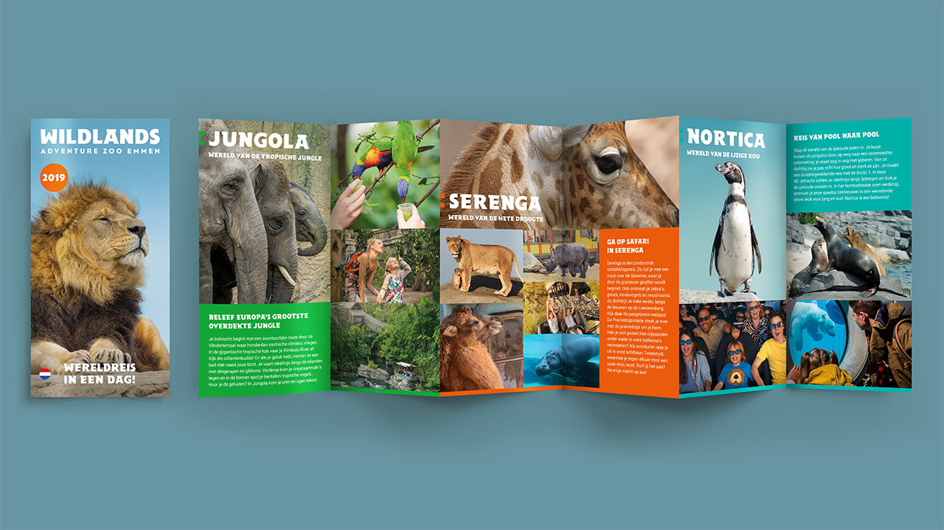

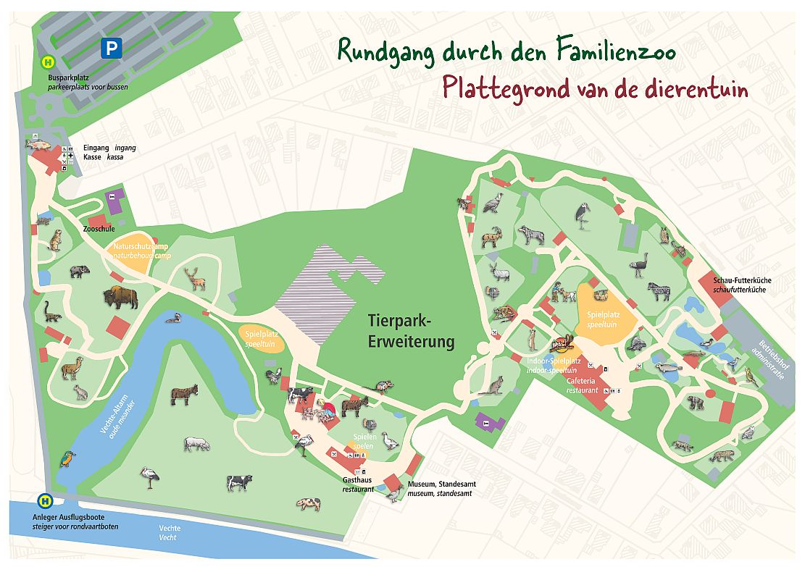

Planning on next page.

|  |  |  |  |
| --- | --- | --- | --- |
|  | Monday of week: |  |  |
| 1 | 26-08 | Introweek new schoolyear, introcamp, special classes |  |
| 2 | 02-09 | Explanation assignment +start work |  |
| 3 | 09-09 | Work on assignment |  |
| 4 | 16-09 | Work on assignment | Bengt & Jeroen away |
| 5 | 23-09 | lesson 1 (practise reading test) | Obligatory |
| 6 | 30-09 | lesson 2 (extra practise test) | Not obligatory |
| 7 | 07-10 | Deadline handing in product | No product = no test |
|  | 14-10 -20-10 | Autumnbreak |  |
| 8 | 21-10 | Lesson 3 (practise reading test) | Not obligatory |
| 9 | 28-10 | Reading test |  |
| 10 | 04-11 | buffer |  |

Used leerdoelen

1. **Je kunt de verzorging van rassen en soorten vissen, reptielen en amfibieën, geleedpotigen en vogels uitvoeren.**
2. **Je kunt de materialen en producten die horen bij de verschillende diersoorten benoemen.**
3. **Je kunt de huisvesting van verschillende diersoorten benoemen.**

English: vocational vocab + skill: reading