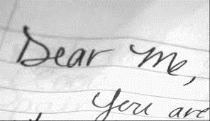

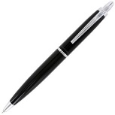**Who are you?** What or who made you who you are today? Everybody has a past. Sometimes good, sometimes bad, but we can only look back at it. But what if someone had given you some advice? What if you had met someone? What if….

**You are going to write to yourself at a younger age.** It can be your childhood self or yourself just a few years back. You can offer advice, compassion, explanation, forgiveness, or praise. Or you can simply recount an experience you had and how it impacted you as your adult self now.

**Try to see this younger self as a real and separate person** when you write the letter. This exercise helps you think about your reader as a real person with emotions — a person who can be moved and inspired by your writing. Try not to overthink this exercise. Spend a few minutes deciding the core message of the letter to yourself, and then just start writing … without filters.

**So now**…get comfortable, don’t speak to any other students, try to get into the flow and start writing!

