Out of class assignment schoolweek 4.(IF-sentences)

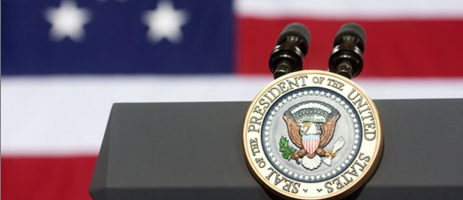

The race for the American Presidency is in full swing.

During these elections, candidates go out and try to win votes by mailing flyers detailing why you should vote for them.

Below is an example of one such flyer.

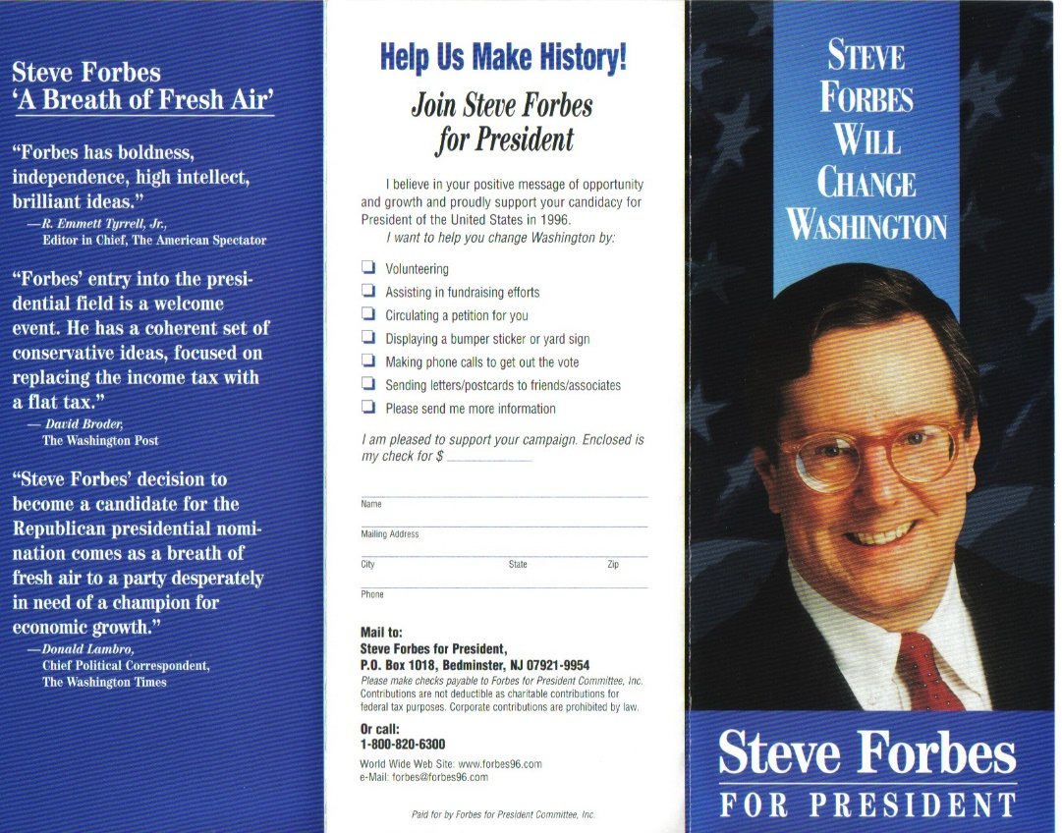Your assignment for today is to create a flyer about yourself. Pretend you are in the race to become president and tell your people why they should pick you. How are you going to change the country? What are some of the problems you are going to solve? Make sure to include lots of slogans (korte zinnetjes die iets zeggen over jou en de dingen die je wil veranderen: bv. J.Wintraecken: the winds of change”. Keep it to 1 page, but write at least half a page of words. Make sure your flyer looks appealing! For more examples search google images (afbeeldingen) for “campaign flyer”. Good luck!

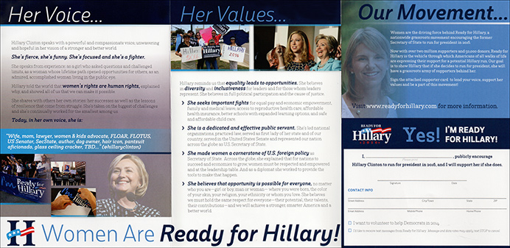

*If you vote for Wintraecken, you vote for stability, security and free kittens for everyone! That’s right! FREE KITTENS!\**

*Why choose J. Wintraecken?*

*“If I get elected, I will work my ass off to bring every household in America –AND THE WORLD!- a free kitten.* Why? I believe that we will be able to boost the economy if everyone has a cute little kitten at home.”*

**“*Jeroen Wintraecken would be fine president...I think.*”   
–Telegraph.co.uk**

“*He’s so tall and handsome as hell*.”   
–Taylor Swift

“*Finally a candidate I can relate to*!” –Bono

*“They don’t call him the ‘winds of change’ for nothing!”* –Bean Restaurant Tasty Bean

“*erm...well I guess he looks okay to me, I dunno”* –random lady in the street

*If you want a free kitten please donate $50 to Wintraecken campaign. Provide your details and creditcardnumber and if Jeroen becomes president, you will get a free kitten! (maybe)

YES I want a free kitten! And so I will vote for J.Wintraecken!

Name: _______________________  
Address: _______________________

Creditcard number: _______________________________



He will change America! For the better! Also: kittens!