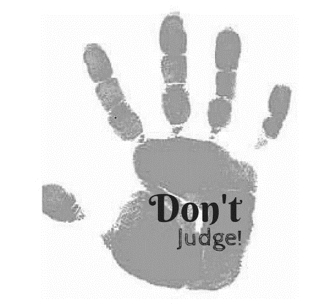**The monster story**

**We all judge…**

It is easy to judge, but hard not to. Who are we judging and upon what do we base our judgements? Do we really know that person? How often have you been proven wrong?

**I want you to draw a monster…**

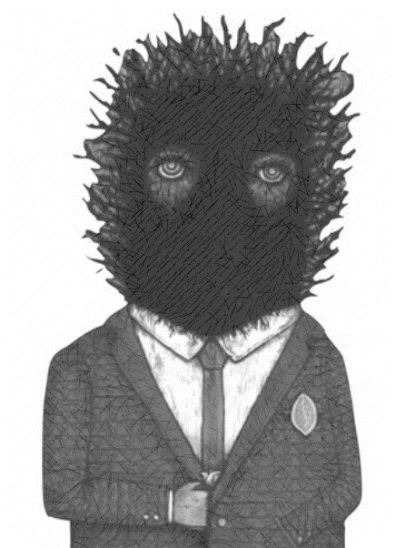You are going to draw a monster. Use your imagination, be creative and do the best you can and remember, he or she is going to be the main character in your story.

**Your assignment** is to write a plausible backstory for the monster that makes it a sympathetic character. Prove that we judge too easily, take me on a journey …