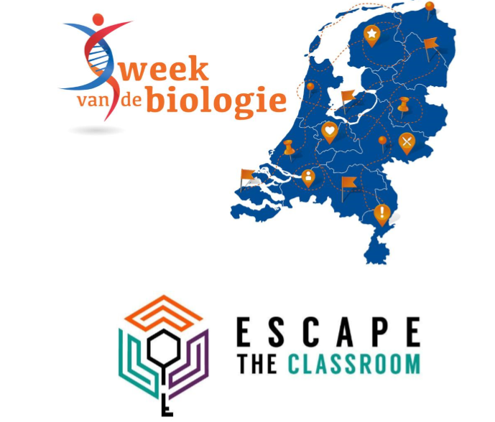

**MasDiv English Version**

Print this document

* In Color
* One-sided
* For each Team

Wolves In the Netherlands

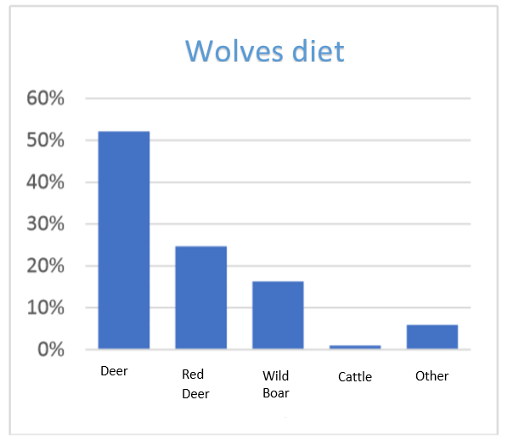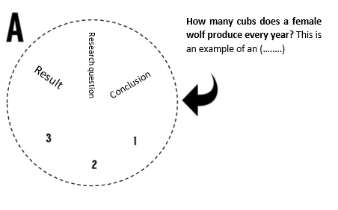Wolves are slowly returning to the Netherlands. In March 2015, a wolf roamed through Drenthe and Groningen for a while. The animal came from Lower Saxony (Germany), and the animal eventually we returned there. This was the first certain wolf sighting in the Netherlands in about 150 years. Can you help our research on wolves?

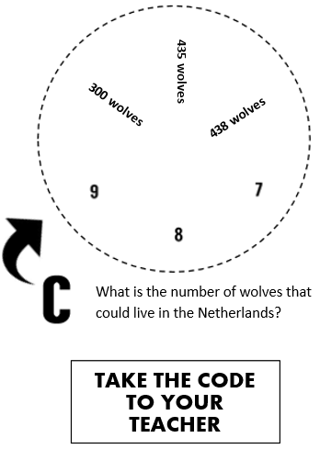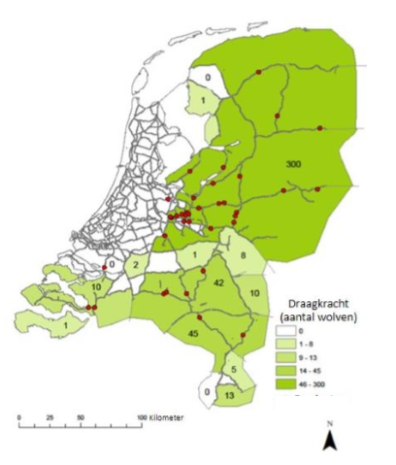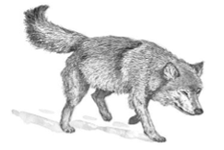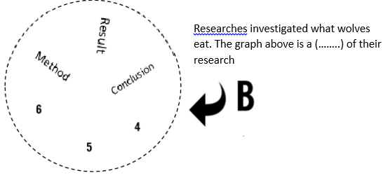

Researchers****

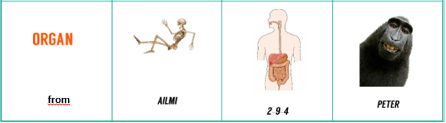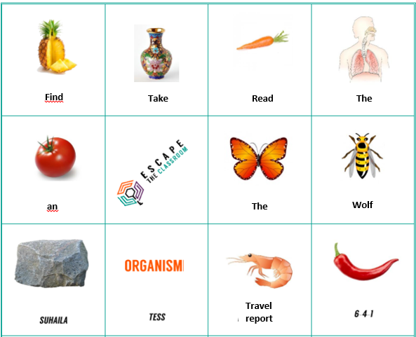**What is it?**

**The**

**Read**

**Take**

**Find**

**Find**

**an**

**by**

**Cross out the right answers**

1. What is another word for living being?

2. What is lifeless (never lived)?

3. What is a fruit?

4. What is the digestive system?

5. What is an insect?

6. What is a skeleton?

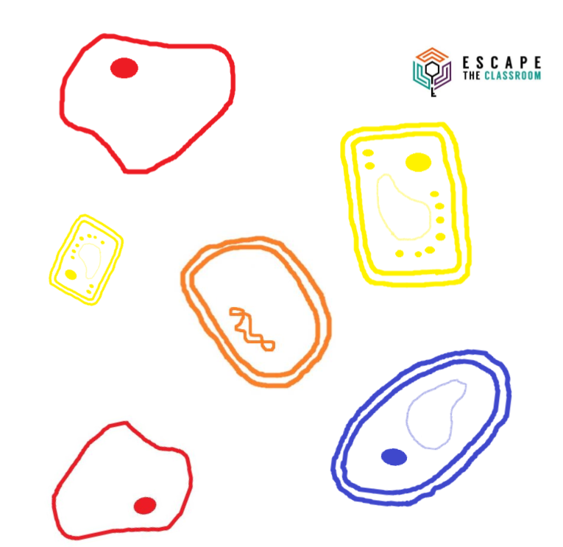

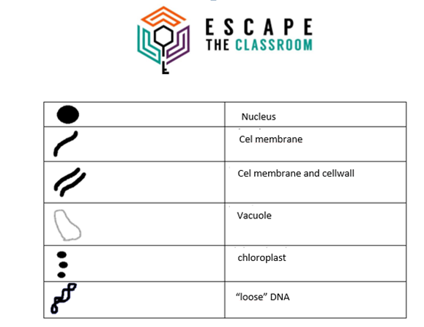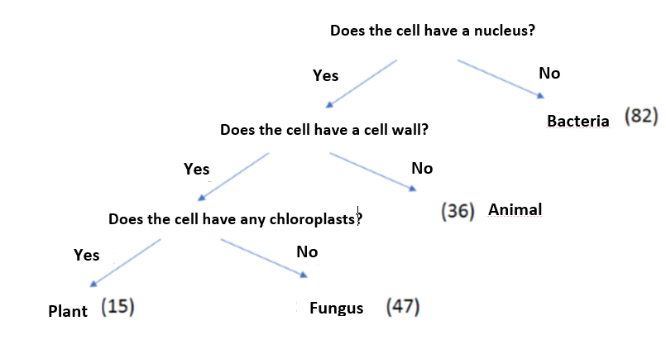

Chloroplast

“loose” DNA

Cel membrane

Cel membrane and cellwall

Nucleus

Vacuole

**Travel report Tess**

My vacation did not start that well! We went to Spain for two weeks, but on the second day I became very ill. I had two days of health issues because I had not seen that there was mold * on the bread that I ate! Fortunately, I really enjoyed my second week. With my sister I then snorkeled a lot, we saw bream * and a seahorse *. So beautiful to see them in their real environment! My father likes walking a lot and we visited a nature reserve. It was really so beautiful, because of all cacti * you really had the idea that you were in a completely different country.

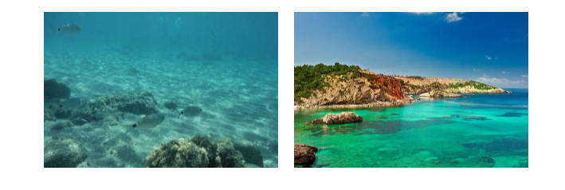

**Travel report Peter**

In the first week of the summer holidays, my parents and I went to France by car. We stood in the traffic jam for hours but luckily we had enough drinks, sandwiches and apples * with us. However the view during the drive was fantastic, in France you have the most beautiful sunflower fields *. Once at the campsite we immediately set up the tent and we went to the pool. After swimming we went to get some food, my mother loves that French blue cheese *, I think it's filthy. After a good night's sleep we went to discover the surrounding area. We walked through a beautiful nature reserve and even encountered a snake *! Fortunately the snake was not poisonous according to my father.

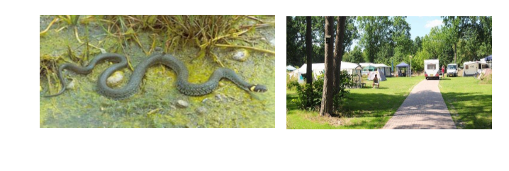

**Travel report Ailmi**

This summer I traveled to Texel (in the Dutch Wadden Sea) with my parents and brother! We had to go by boat and then we saw the first seals * already. On Texel we visited Ecomare where you can learn all about them. We also walked a lot through the Slufter, which is a very beautiful nature area. I have seen a lot of spoonbills * in real life! Because of the beautiful heather * that grew everywhere, a large part of the nature area turned completely purple. I also learned that they used to make Texel’s sheep cheese with shovels! Nowadays that is not allowed anymore because they are afraid of the wrong bacteria *.

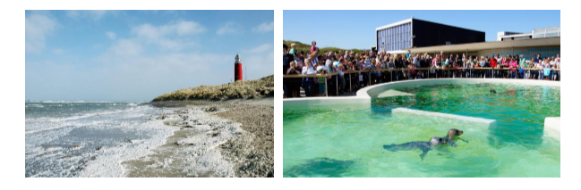

**Travel report Suhaila**

On Friday evening after the last day of school, I immediately got on the plane! We travelled to Morocco where we stayed for a few weeks. We have been in Marrakech for the first time for a couple of days, which is a busy and warm city. Very nice and delicious juice of oranges * on the big square! In the evening there were also people with snakes * and monkeys * which you could take a picture with , I found that a little pathetic sometimes. Then we drove to my uncle and aunt who have a house in the Atlas Mountains, then you immediately notice that it is a lot cooler there.

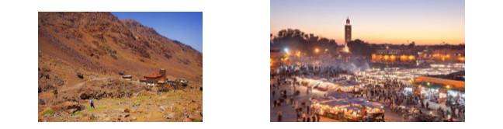

|  |  |
| --- | --- |
| Organism | Score |
| Animal | 16 |
| Plant | 8 |
| Bacteria | 34 |
| Fungus | 21 |

Clue: Score Organism+ Score Organism+ Score Organism+ Score Organism

**Adding Functions**

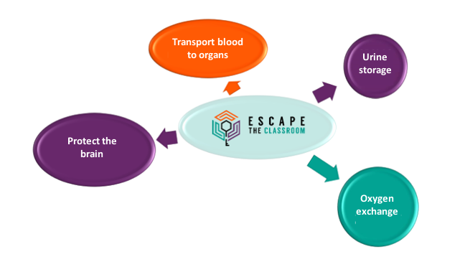

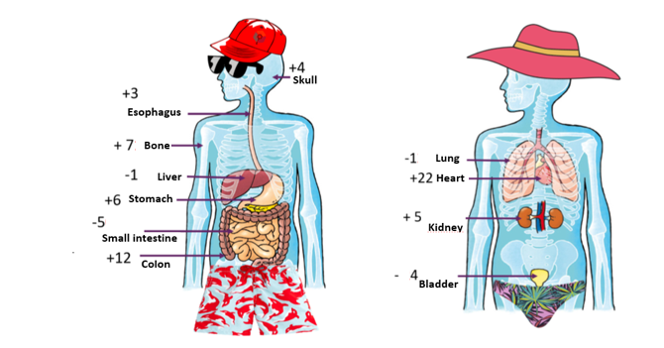

**Oxygen exchange**

**Urine storage**

**Protect the brain**

**Transport blood to organs**