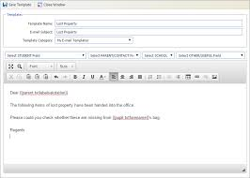**Remember Indi?**

**Re**

You watched Indi’s vlog. She introduces herself and a few of her family members. You are going to send her an email/

But first, let’s watch a short video on how to write an email. Take notes on the tips and tricks of writing an informal email:

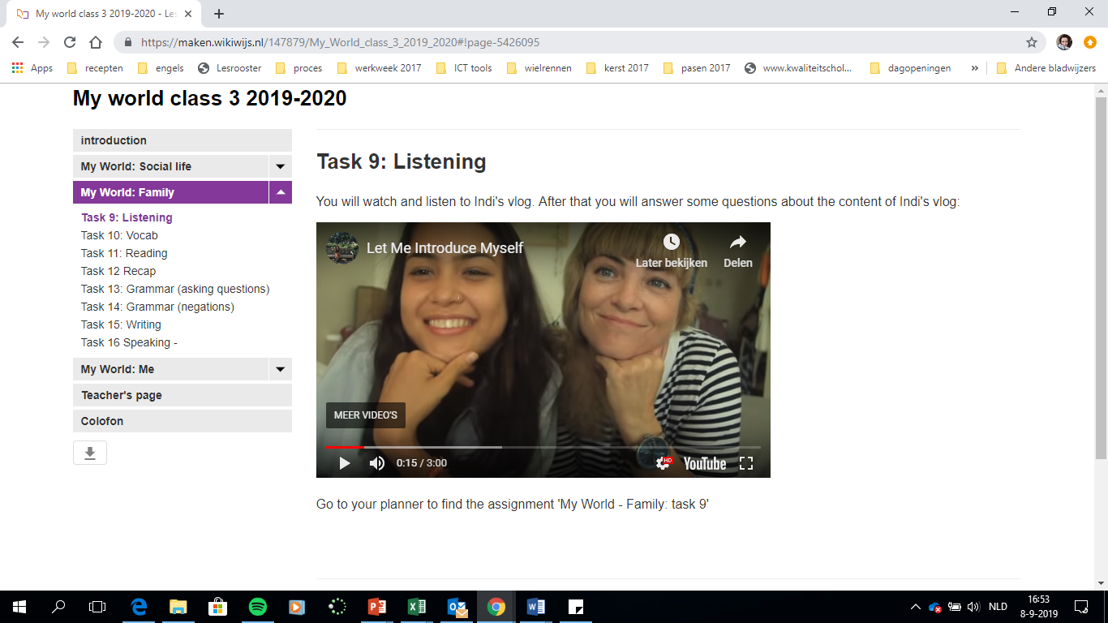

**How to write an email**

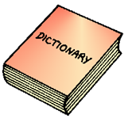The video explains how to write an email in six steps. Write down steps next to the email below:

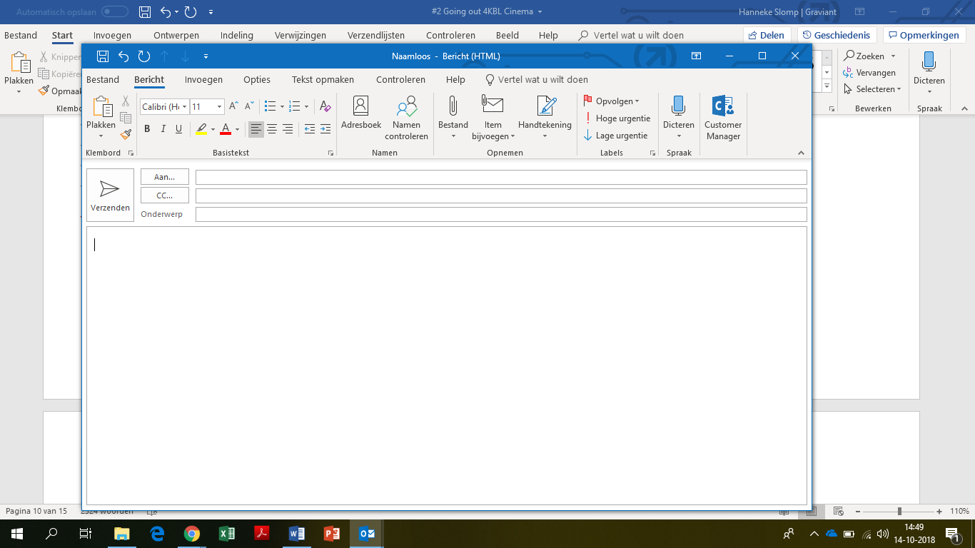

*Step*

*1*

*1 2*

*Step 6*

*Step 3*

*Step 5*

*Step 4*

*Step 2*

After writing:

**Let’s get started**

Indi has sent you an email:

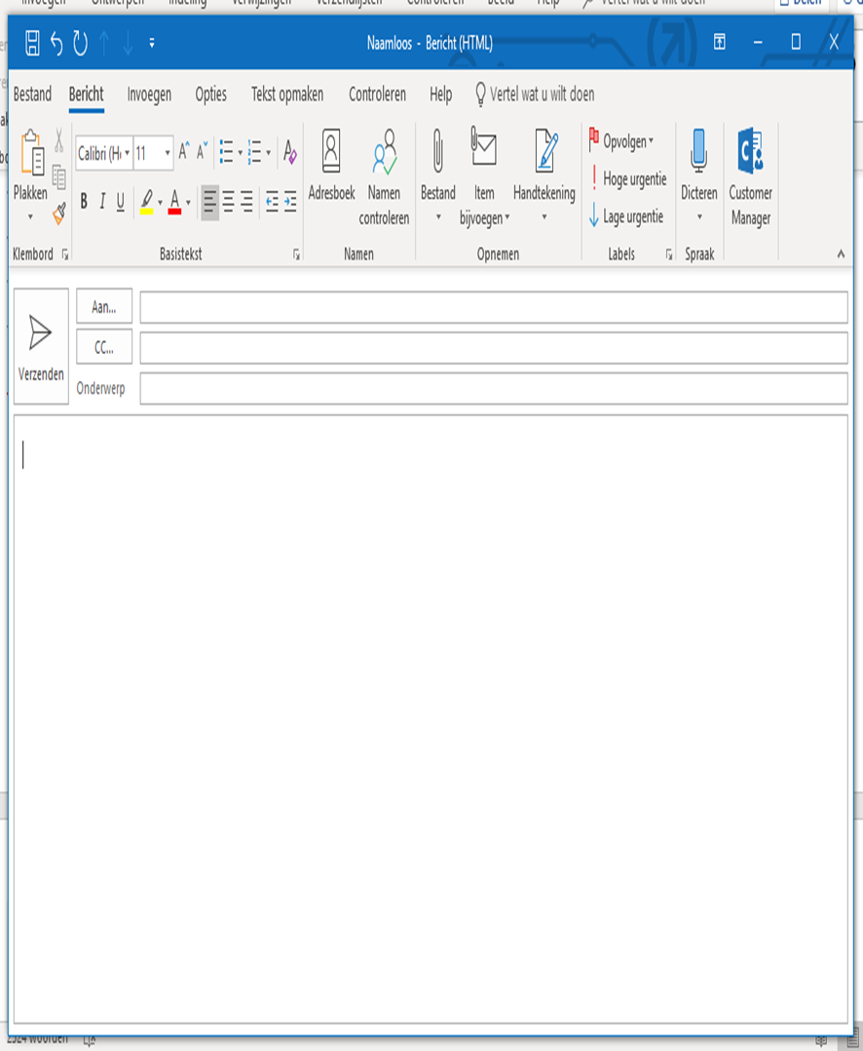

Hi there,

How are you? I am fine! Thank you so much for liking my video. I would like to know how you feel about my vlog, could you give me some feedback?

I love travelling, but I have never been to the Netherlands. That’s where you are from, isn’t it? Could you tell me a little bit more about yourself and your life? Is it anything like mine or is it very different? I would love to read about that.

I really hope to hear from you soon!

Kind regards,

Indi

Prepare for writing an email. Let’s see what you need to write first. Use the vocabulary list to help you:

1. Fill out the send/receive information. Receiver: [Indi.Setyawan03@hotmail.com](mailto:Indi.Setyawan03@hotmail.com)

Keep the subject short! 2-5 words maximum

Your email address:

1. Think of a subject of your email

1. Start the email in a correct way

1. Tell Indi in detail what you like about her vlog

1. Write about two similarities/differences between yourself and Indi

**Check yourself**

Use the rubric to check task 61 before you write the actual email.

|  |  |  |  |
| --- | --- | --- | --- |
| What? | *Score* | | *punten* |
| *Content* | *Alle 5 de punten zijn aanwezig in begrijpelijk Engels.*  *Ten minste 4 punten zijn aanwezig in begrijpelijk Engels.*  *Ten minste 3 punten zijn aanwezig en in begrijpelijk Engels.*  *Minder dan 3 punten zijn aanwezig en in begrijpelijk Engels.* | *9*  *6*  *3*  *0* | |
| Grammar | *De tekst is (vrijwel) helemaal correct.*  *De tekst is redelijk correct.*  *De tekst is matig correct.*  *De tekst zit vol fouten.* | *3*  *2*  *1*  *0* | |
| *Spelling, interpunction & lay-out* | *Spelling, interpunctie en hoofdletters zijn voldoende*  *Spelling, interpunctie en hoofdletters zijn onvoldoende.* | *1*  *0* | |
| *Conventions/lay-out:*  1.Correct email adres  2Correct onderwerp  3Correcte aanhef (Dear,)  4Correcte afsluitende groet  5 alinea-indeling | *Alle 5 de punten zijn aanwezig en goed uitgevoerd*    *Ten minste 4 punten zijn aanwezig en goed uitgevoerd*  *Ten minste 3 punten zijn aanwezig goed uitgevoerd*  *Minder dan 3 punten zijn goed uitgevoerd* | *3*  *2*  *1*  *0* | |

**Task 62B Feedback**Work with a classmate and give each other feedback on how to improve: what went well and what can be improved? Give each other first a TOP and then a TIP:

**My TOPS**:



**My TIPS:**