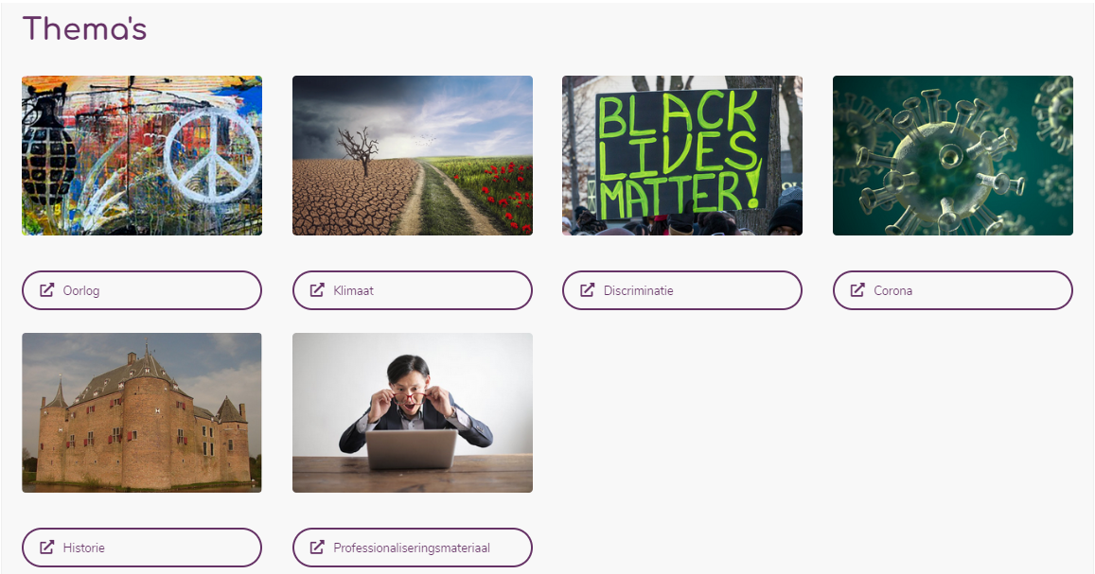
Oorlog
(was: Oekraine)
https://commons.wikimedia.org/w/index.php?search=oorlog+oekraine&title=Special:MediaSearch&go=Go&type=image (dit slaat op Oekraïne)
https://commons.wikimedia.org/w/index.php?search=war+and+peace&title=Special:MediaSearch&go=Go&type=image (dit is algemeen)

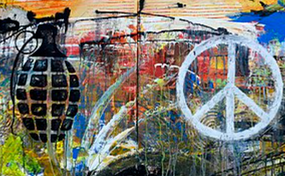
https://commons.wikimedia.org/w/index.php?search=stop+war&title=Special:MediaSearch&go=Go&type=image (algemeen)
Klimaat
https://commons.wikimedia.org/wiki/File:Climate_change_mitigation_and_adaptation.png
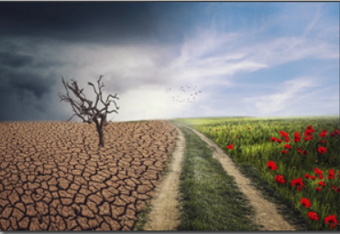
discriminatie
https://commons.wikimedia.org/w/index.php?search=black+lives+matter+sign&title=Special:MediaSearch&go=Go&type=image
https://commons.wikimedia.org/wiki/File:Black_Lives_Matter_Sign_-_Minneapolis_Protest_(22632545857).jpg
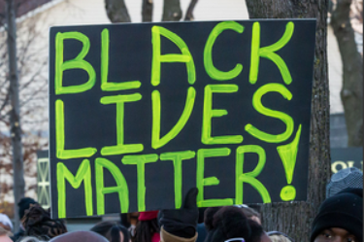
covid
https://commons.wikimedia.org/wiki/File:SARS-CoV-2_illustration_(20).jpg rood
https://commons.wikimedia.org/wiki/File:Coronavirus_SARS-CoV-2.jpg lichtblauw
https://commons.wikimedia.org/wiki/File:Novel_Coronavirus_SARS-CoV-2_(49597768457).jpg vaag blauwig
https://commons.wikimedia.org/wiki/File:Corona_virus_Covid-19_FC.jpg groenblauw
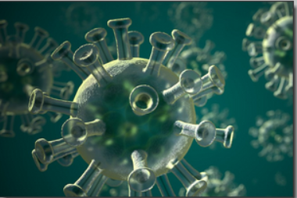
historie
https://commons.wikimedia.org/w/index.php?search=kasteel+ammersoyen&title=Special:MediaSearch&go=Go&type=image
https://commons.wikimedia.org/wiki/File:KasteelAmmersoyen.jpg
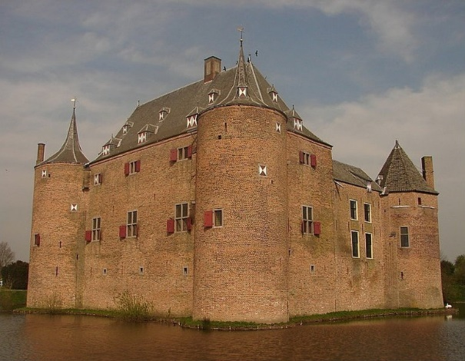
Professionalisering
https://www.pexels.com/nl-nl/foto/verbaasd-formeel-mannetje-dat-laptop-het-scherm-bekijkt-3760809/


