**Fishery**

# Abstract

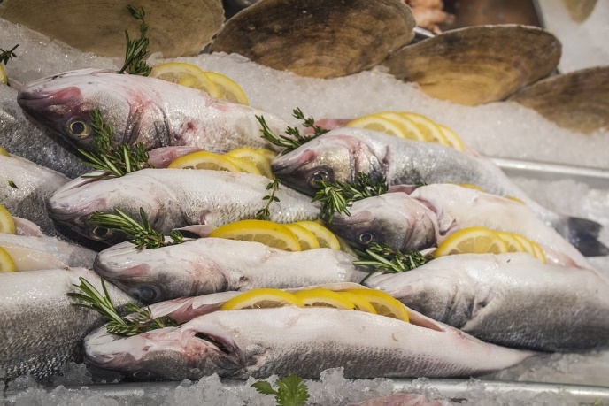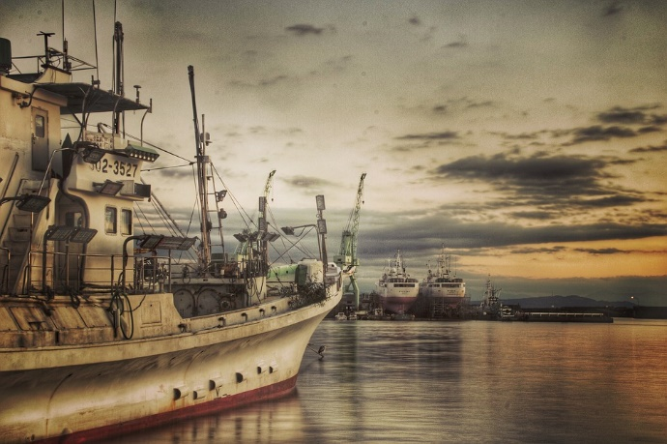The ocean is a valuable resource for food and income. All countries and cultures have their own traditions when it comes to eating fish or fishing. Overfishing has led to a decrease in the diversity of sea life; damaging coral and diminishing certain types of fish and other sea animals.

Fishing links very closely to the daily lives and diets of students. In this activity students are asked to investigate the case of dynamite fishing in Tanzania. This activity is multi- and interdisciplinary with a base in physics, chemistry and biology. During the tasks students will find out more about sound waves, connect biological consequences to physical changes and understand how chemical characteristics attribute to physical phenomena.

# Lesson implementation

As an introduction students work on an investigation focused on their prior knowledge of fishery. Possible questions up for investigation are:

* How many times a week do you eat fish?
* Are there any other products you might use that are derived from fish/ocean creatures?
* Can you think of other cultures were fish or fisheries might be a very important aspect of daily life?
* How would you try to catch fish:
  + Within a radius of 10 kilometers from your school?
  + In other areas of your country?
  + In other places in the world?

After this, dynamite fishing is introduced with a video either in English or local language[1]. The topic can then be investigated from multiple angles.

## Physics and biology

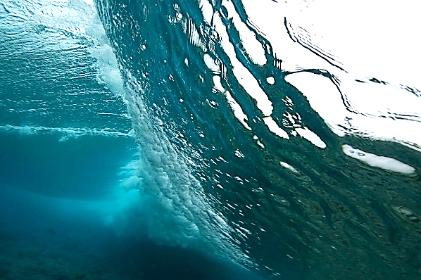The physics and biology activities below focus on the waves produced by exploding dynamite:

* Investigate which physical (physics) mechanism is responsible for the death of the fish when dynamite is used by the fishermen.
* Explore blast waves under water by drawing, lab experiments, slow-motion video examination etc.
* Why does dynamite kill fish in a certain(specific) area? Which factors define that area?
* Which other organisms are killed by the blast and why? Is there also a perimeter to the area in which they are affected? And is that the same as for fish? (why or why not)
* Do (shock)waves travel faster through air or water? Try to explain why.

Very advanced students could even be introduced to the ‘doppler effect’

## Chemistry

[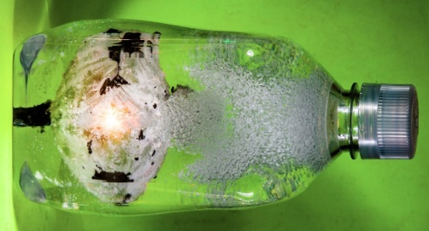](https://www.google.nl/url?sa=i&rct=j&q=&esrc=s&source=images&cd=&cad=rja&uact=8&ved=0ahUKEwjghsPs89zXAhUHKsAKHVLSDvwQjRwIBw&url=https://www.youtube.com/watch?v=Aan-kc-9E3A&psig=AOvVaw2iTdkrVCMDi06D64moJxXk&ust=1511808492693250)The chemistry activities focus on the characteristics of dynamite:

* Investigate where dynamite comes from and how it works.
* Watch the online science video of "How stuff works" about dynamite: <https://science.howstuffworks.com/question397.htm>
* Which substance makes it possible for dynamite to explode under water?
* Who invented/discovered this chemical compound? What did he do after he made the discovery?
* Take a look at the next video on underwater explosions from the Slow mo guys: <https://www.youtube.com/watch?v=E5rGFZWQfzk>. Can you answer their question at the end of their video? What do you think happens after the initial blast?

## Interdisciplinary

After the research phase the students can exchange their findings and/or put what they learned into perspective by designing a solution for dynamite fishing in Tanzania. When designing solutions students have to think about the needs of the fishers (food, money, care for their children) and try to be creative in using the possibilities of their surroundings (for example sustainable coral reef exploitation by tourism).

1. Dynamite fishing (Dutch subtitles): <https://www.youtube.com/watch?v=n75prj6hyus>

   or in English: <https://www.youtube.com/watch?v=gOyusJVKxvc>