



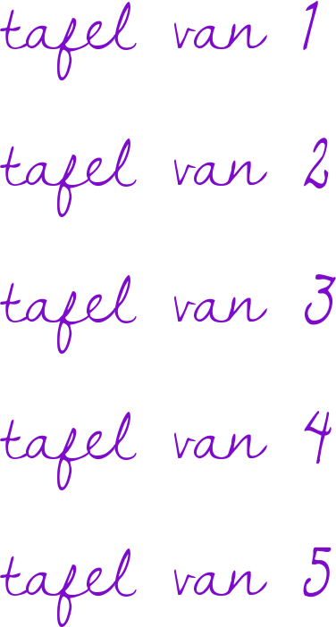 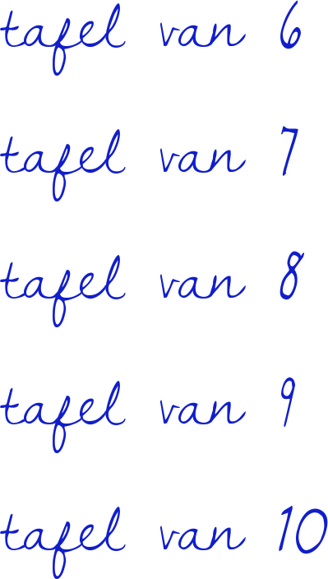





https://fontmeme.com/temporary/10ae680f8766f431773b810d6d5ec475.png

https://fontmeme.com/temporary/575e93df65376ae2037cbdc162d81ef3.png