Kernkwadrant 1:

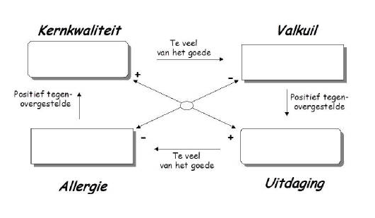

Kernkwadrant 2:

