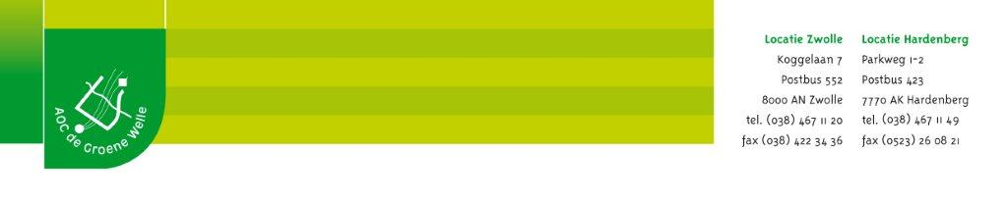

Logboek Weeknr:

Welke taak heb je uitgevoerd?
____________________________________________________________________________________________________________________________________________________
__________________________________________________________________________

Met wie heb je samengewerkt en hoe zijn de taken verdeeld?
____________________________________________________________________________________________________________________________________________________
__________________________________________________________________________

Wat zijn de aandachtspunten? Waar moet je op letten bij de uitvoering?
______________________________________________________________________________________________________________________________________________________________________________________________________________________________

Welke materialen en middelen heb je gebruikt bij deze taak?
1.________________________ 6.________________________
2.________________________ 7.________________________
3.________________________ 8.________________________
4.________________________ 9.________________________
5.________________________ 10.________________________

Beschrijf, stap voor stap, hoe je de taak hebt uitgevoerd.
1_________________________________________________________________________2_________________________________________________________________________3_________________________________________________________________________
4_________________________________________________________________________5_________________________________________________________________________6_________________________________________________________________________
7_________________________________________________________________________8_________________________________________________________________________9_________________________________________________________________________
10________________________________________________________________________

Vind je dat je de taak goed hebt uitgevoerd? Leg uit.
__________________________________________________________________________________________________________________________________________________________________________________________________________________________________________________________________________________

Vindt de praktijkopleider dat jij je taak goed hebt uitgevoerd? Leg uit.
______________________________________________________________________________________________________________________________________________________________________________________________________________________________

Handtekening praktijkopleider: Plaats, datum:

