[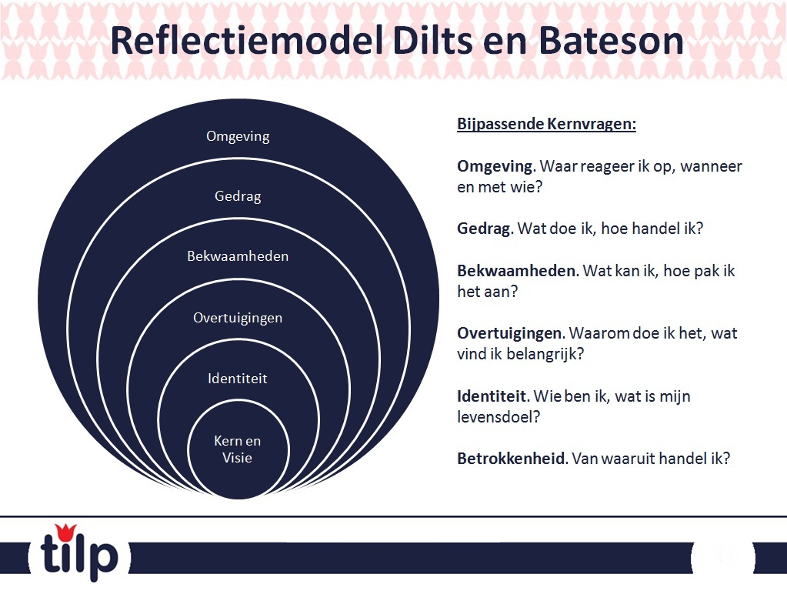](http://www.google.nl/url?sa=i&rct=j&q=&esrc=s&source=images&cd=&cad=rja&uact=8&ved=0ahUKEwiq1K6ziInNAhUHDcAKHaEWD3UQjRwIBw&url=http://www.tilp.nl/index.php/inspiratie-downloads/98-reflectie&bvm=bv.123664746,d.d2s&psig=AFQjCNF_71tEes9diZSqsqWOAZ6As29pbw&ust=1464946976496956)

[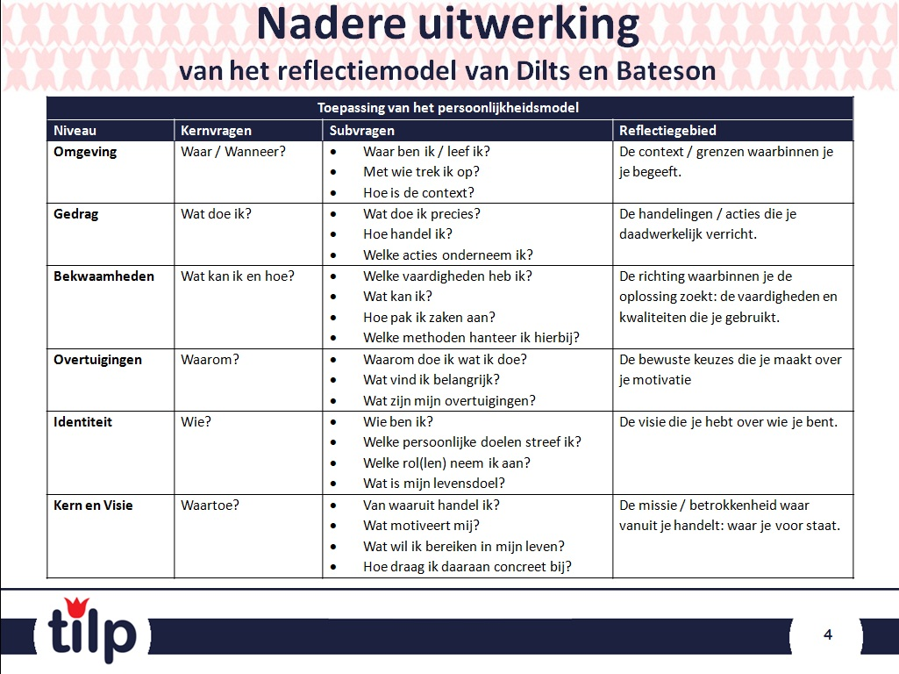](http://www.google.nl/url?sa=i&rct=j&q=&esrc=s&source=images&cd=&cad=rja&uact=8&ved=0ahUKEwiz-rSjiInNAhXEI8AKHcA8AhEQjRwIBw&url=http://www.tilp.nl/index.php/inspiratie-downloads/98-reflectie&bvm=bv.123664746,d.d2s&psig=AFQjCNF_71tEes9diZSqsqWOAZ6As29pbw&ust=1464946976496956)