UK still has the highest rate of teen pregnancies in Western Europe despite 25% fall in the last decade
- 19.7 births per 1,000 women aged 15-19 in the UK in 2012, study shows
- Figure is much higher than the EU average of only 12.6 births per 1,000
- Worldwide figures show Switzerland had the lowest rate at 3.4 births
- The highest teen pregnancy rate was in Azerbaijan at 50.0 births
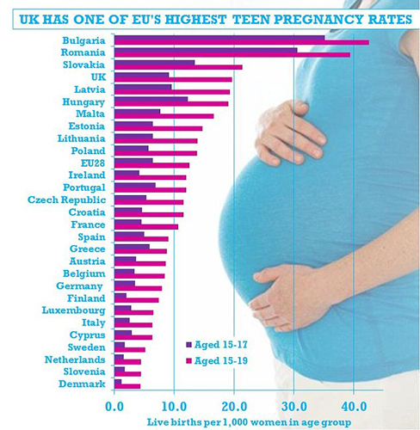
Britain has the highest teen pregnancy rate in Western Europe, new figures showed today.
Only Bulgaria, Romania and Slovakia have a bigger problem with girls aged 15-19 giving birth, the Office for National Statistics said.
Tackling high levels of teenage pregnancies is linked to the struggle to break the cycle of ill-health and poverty, the ONS said.
According to the study into how European countries compare, the UK birth rate among women aged 15-19 was higher than the average across the whole of the 28 countries in the European Union.
For every 1,000 women in the age bracket in the UK, there were 19.7 births, compared to only 12.6 births across the EU.
The UK figure is significantly higher than other major European countries like Germany (8 births per 1,000), France (10.7) and Spain (9.1).
Europe's lowest teenage birth rate was in Denmark (4.4), Slovenia (4.5) and the Netherlands (4.5).
The long-term trend shows that teenage pregnancy rates are falling, and faster in countries where it is a bigger problem.
The UK teenage birth rate is down by more than a quarter (26.8 per cent) since 2004 compared to a fall of almost one fifth (18.2 per cent) across the EU as a whole.
A Department of Health spokesperson said: 'Teenage pregnancy rates in the UK are now at their lowest level for over 40 years – but we need to keep up the momentum to achieve the levels seen by our Western European counterparts.
'We know that teenage pregnancy is strongly associated with our most deprived and socially excluded young people, and together with the NHS and local authorities we must continue to make progress.'

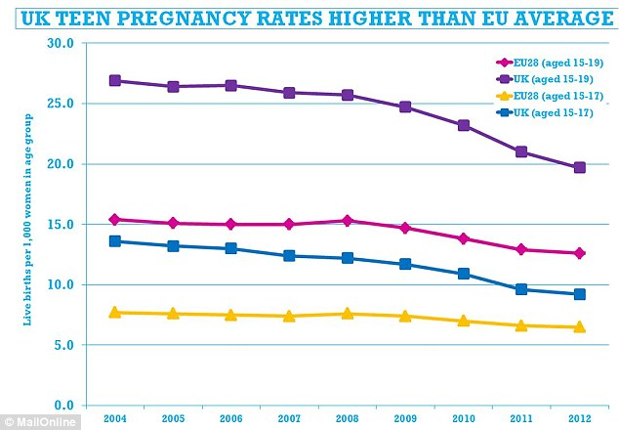
Among countries outside the EU, Switzerland had the lowest birth rate with 3.4 births per 1,000 women aged 15-19 in 2012.
Azerbaijan, which borders Russia and Iran, had the highest rate at 50.0 births per thousand.
In 2012, the birth rate among young women was 16.1 per 1,000 women aged 15-19 in Australia, 24.9 in New Zealand and 29.4 in the United States, the ONS said.
The ONS said: 'There is a great deal of interest in teenage pregnancy levels in the UK and how these levels compare to other countries within Europe and the world.
'Globally, adolescent pregnancy and childbirth is regarded as a major contributor to maternal and child mortality and to the cycle of ill-health and poverty.
'This is largely as a result of the associated socio-economic factors before and after pregnancy as opposed to the biological effects of young maternal age.'
Read more: http://www.dailymail.co.uk/news/article-2794234/uk-highest-rate-teen-pregnancies-western-europe-despite-25-fall-decade.html#ixzz3xluaudfq

