

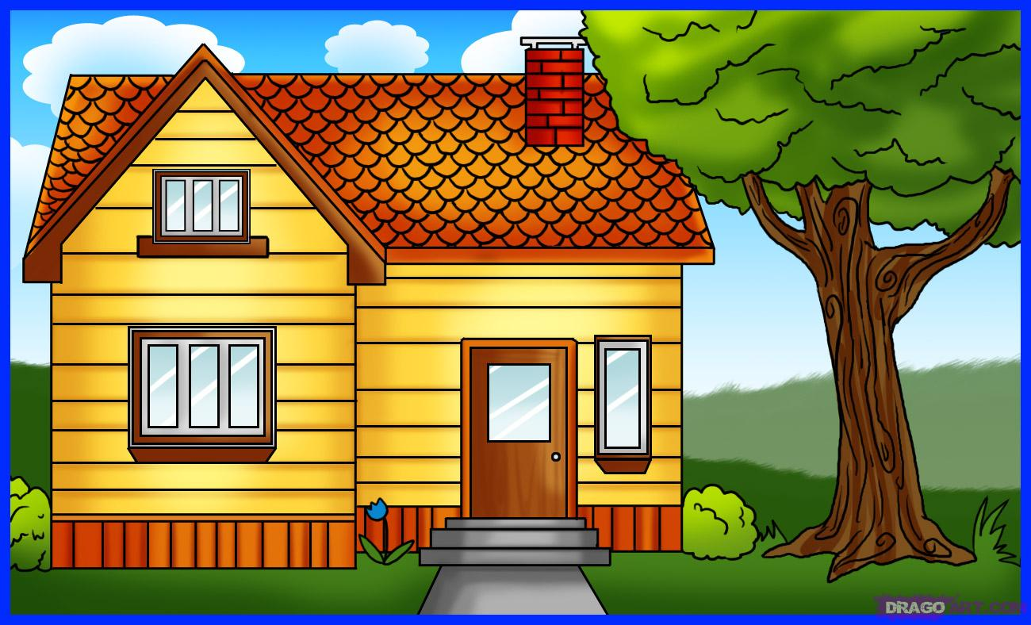
1.Read the text:
Hi! My name is Laura. I live at 34 Forest Street in a detached house. It is very beautiful indeed. Have a look!
It is a one - storeyed building with the garden full of flowers. There is a kitchen, a dining - room, a sitting - room, my father’s study, two bedrooms and a bathroom.
Our kitchen is large and comfortable. I always help my mother with

the meals. Our sitting – room is very cosy too. There is a sofa, two armchairs and a carpet on the floor. Opposite the sofa there is a fire place. The TV set is in the left corner. There are many pictures on the walls. We like to gather here in the evenings.
In my father’s study you can see two huge bookcases full of books, a computer, a table and three chairs.
In the bedroom there is a bed, a wardrobe, a bedside table and a mirror on the wall.
We also have an attic where you can find my room. You can see a sofa, a table, two chairs, a computer, a bookcase and many modern posters on the walls. There is also a green carpet on the floor. I like my room. I spend a lot of time with my friends here.
2. Choose True(T),or False(F) statements:
1. Laura lives in Green Street.
2. She lives in a detached house.
3. It is a three-storey-ed building.
4. There are four rooms there.
5. Their kitchen is large and comfortable.
6. Laura helps her mother with the meals.

3. Answer the questions:
1. Where does Laura live?
2. I her house a three-storeyed building?
3. How many rooms are there in her house?
4. What is there in the sitting-room?
5. What can you see in the father’s study?
6. What can you find in Laura’s room?
4. Quiz: guess what place it is:
1. Here we cook meals with my mother. – It is a ______________.
2. Here my father works. - It is a _____________.
3. Here we have meals with our friends. – It is a _______________.
4. Here we watch TV, talk, read. – It is a ___________________.
5. Here my parents sleep. – It is a ________________.
6. Here we plant flowers, trees, bushes. – It is a _________________.

KEY:
2. Choose True(T),or False(F) statements:
1. Laura lives in Green Street. F
2. She lives in a detached house. T
3. It is a three-storeyed building. F
4. There are four rooms there. F
5. Their kitchen is large and comfortable. T
6. Laura helps her mother with the meals. T

4. Quiz: guess what place it is:
1. Here we cook meals with my mother. – It is a kitchen.
2. Here my father works. - It is a study.
3. Here we have meals with our friends. – It is a dining-room.
4. Here we watch TV, talk, read. – It is a sitting-room.
5. Here my parents sleep. – It is a bedroom.
6. Here we plant flowers, trees, bushes. – It is a garden.

