**Prepositions of place**

**in on under behind at between**

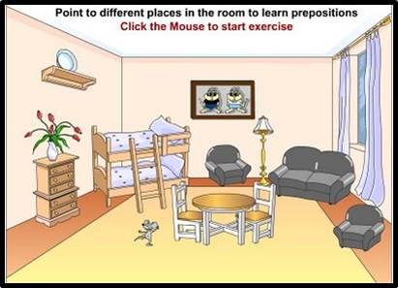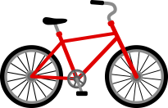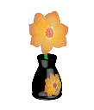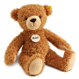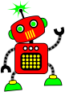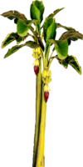

1. There is ___ ball _____ the armchair.

2. There is ___ umbrella ____ the floor.

3.  There is ____ picture _____ the wall.

4. There is ____ apple _____ the bed.

5. There is ____ bike _____ the floor.

6. There is _____ vase ______ the table.

7.  There is _____ flower _________ the sofa.

8. There is _____ chair ______- the table.

9. There is _____ lamp _________ the sofa and the armchair.

10.  There is _____ robot _______ the bed.

11. There is _____ mouse _______ the chair.

12.  There is ____ window __________ the sofa.

13.  There is _____ flower _______ the vase.

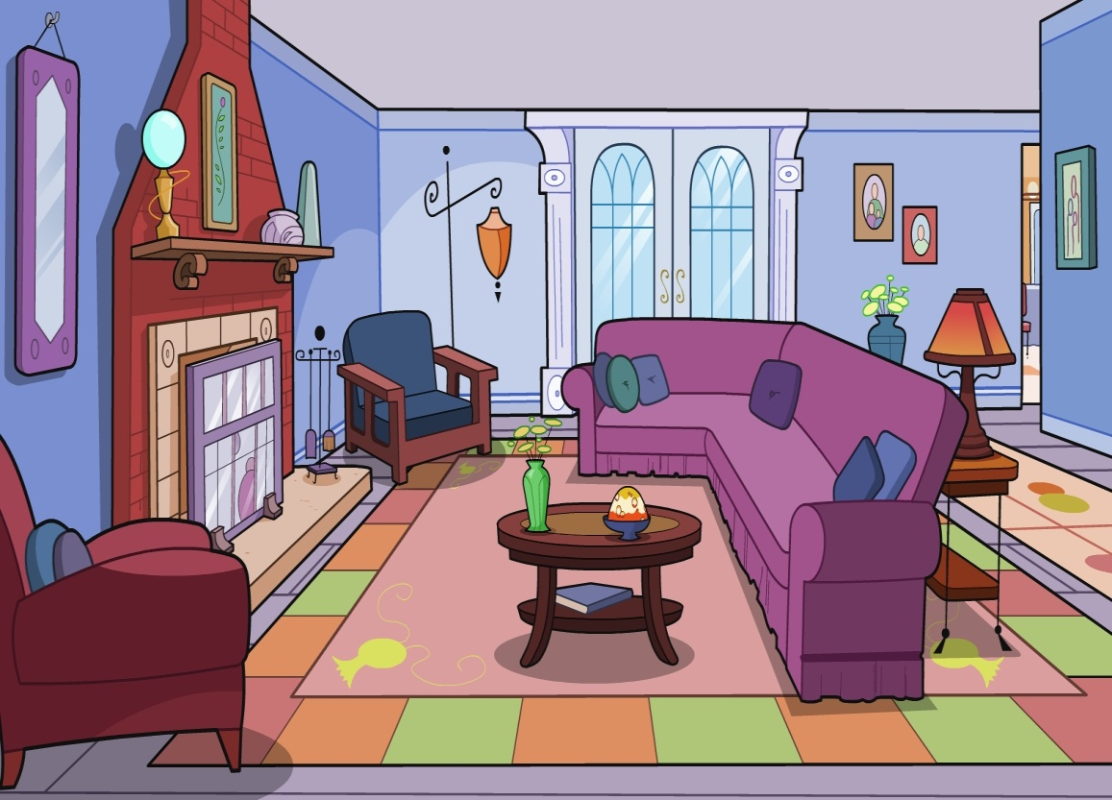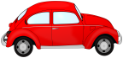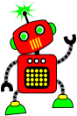

1. There is ___ doll _____ the sofa.

2. There is ___ ball _____ the table.

3. There is ___ cat _____ the armchair.

4. There is ___ apple _____ the table.

5. There is ___ dog _______ the table.

6. There is ___ umbrella _____ the sofa.

7. There is ___ picture _____ the wall.

8. There is ___ vase ____ the table.

9. There ___ robot _____ the floor.

10. There is ___ car _____the armchair.

11. There is __ lamp ________ the sofa.

12.  There is ___ teddy _____ the armchair.