House & Furniture
There is/are; a/an; some/any; place prepositions
- Label the pictures with the correct names. Then match the names of the objects and furniture:
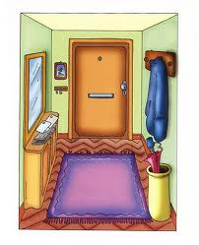
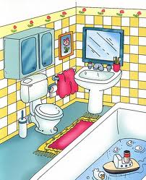
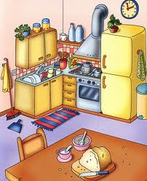
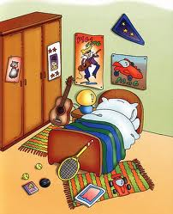
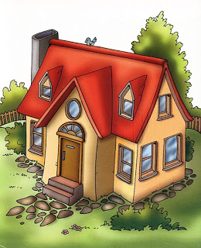
HOUSE & ROOMS
- Living room
- House
- Bathroom
- Hall
- Bedroom
- Kitchen
OBJECTS & FURNITURE
- Sink
- Toilet
- Picture
- Roof
- Door
- Pillow
- Poster
- Garden
- Mirror
- Bath
- Cooker
- Hanger
- Sofa
- Fridge
- Steps
- Lamp
- Curtains
- Cupboard
- Chimney
- Towel
- Wardrobe
- Washbasin
- Umbrella stand
- Rug

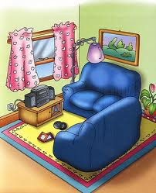

2. Look at the picture and complete with there is/isn’t or there are/aren’t:
1. ____________ a TV in the living room.
2. ____________ a picture on the wall.
3. ____________ two sofas in the room.
4. ____________ three chairs and a table.
5. ____________ a rug under the sofas.
6. ____________ a stereo set under the window.

5. Look at the pictures of the rooms in exercises 2 to 4. Check if the sentences are True (T) or False (F). Correct the false ones.
1. There are two pictures on the wall in the living room.
2. There is a TV in front of one of the sofas.
3. There is a rug in the kitchen.
4. There is a bin in front of the fridge.
5. There is a lamp next to the bed.
6. There are four posters on the wall over the bed.

3. Look at the picture and complete with is/isn’t, are/aren’t, a/an, some or any:
1. There _____ _____ cooker next to the fridge.
2. There _____ _____ plates in the sink.
3. There _____ _____ glasses on the table.
4. There _____ _____ clock over the fridge.
5. There _____ _____ boxes on the floor.
4. Look at the picture and complete with is/are and a place preposition: IN FRONT OF, ON, UNDER, BETWEEN, NEXT TO, OVER.
1. There _____ a guitar _____ the wardrobe and the night table.
2. There _____ two tennis balls _____ the floor.
3. There _____ a rug _____the guitar.
4. There _____ a toy car _____ the magazine.
5. There _____ two posters _____ the wall _____ the bed.
6. There _____ a tennis racket ________ the bed.

ANSWERS:
2. Look at the picture and complete with there is/isn’t or there are/aren’t:
1. There isn’t a TV in the living room.
2. There is a picture on the wall.
3. There are two sofas in the room.
4. There aren’t three chairs and a table.
5. There is a rug under the sofas.
6. There is a stereo set under the window.

3. Look at the picture and complete with is/isn’t, are/aren’t, a/an, some or any:
1. There is a cooker next to the fridge.
2. There are some plates in the sink.
3. There aren’t any glasses on the table.
4. There is a clock over the fridge.
5. There aren’t any boxes on the floor.

4. Look at the picture and complete with is/are and a place preposition: IN FRONT OF, ON, UNDER, BETWEEN, NEXT TO, OVER.
1. There is a guitar between the wardrobe and the night table.
2. There are two tennis balls on the floor.
3. There is a rug under the guitar.
4. There is a toy car next to the magazine.
5. There are two posters on the wall over the bed.
6. There is a tennis racket in front of the bed.

5. Look at the pictures of the rooms in exercises 2 to 4. Check if the sentences are True (T) or False (F). Correct the false ones.
1. There are two pictures on the wall in the living room. F. There is one picture on the wall.
2. There is a TV in front of one of the sofas. F. There is one stereo set in front of one of the sofas.
3. There is a rug in the kitchen. T.
4. There is a bin in front of the fridge. F. There is a bin next to the fridge.
5. There is a lamp next to the bed. T.
6. There are four posters on the wall over the bed. F. There are two posters on the wall over the bed.

