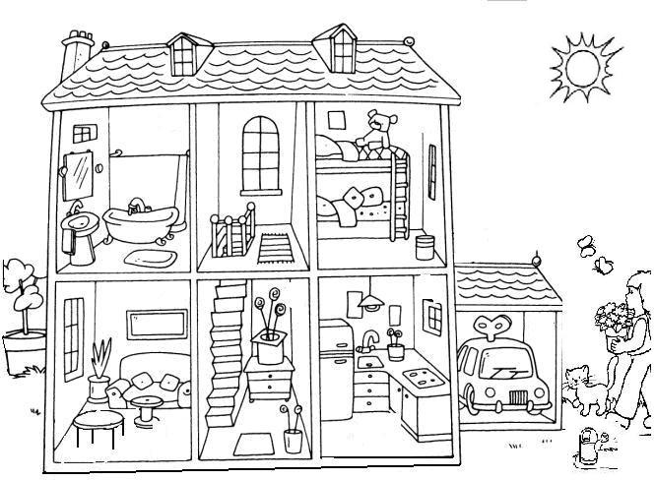

Parts of the House
B
- There is a car in the ..............................................
- There is a teddy in the .........................................
- There are 2 butterflies in the ..........................
- There are 2 pillows in the ....................................
- There is a fridge in the .......................................

MORE SPELLING PRACTICE
1
2
3
4
5
6
7

A
LABEL THE HOUSE

garage
hall

bathroom

living -room
kitchen
C
YES or No
- There is a cat next to the house. _____
- There is a hippo on the bed. _____
- There are two monkeys in the bath. _____
- There is a sink next to the fridge. _____
- There is a mouse under the coffee table. ____
bedroom
garden

