- Look at the following picture. Then, complete the tasks below. Share your answer.

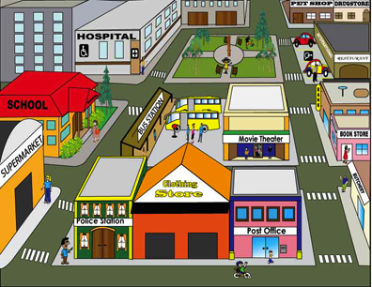

Picture made by: Lic. Juan Diego Guzmán V.

Instructions: Locate the following places by writing the correct prepositions.

Far from / next to / in / behind / opposite / across from / between / close / in front of/

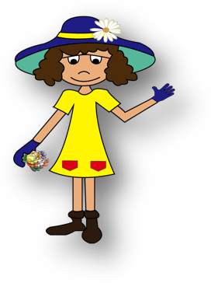
- The Clothing Store is _____________ the post office and Police station.
- The bus station is _______________ Movie Theater.
- Supermarket is _______________ drugstore.
- The School is ______________ the bus station.
- The park is ____________ the city.
- The butchery is _________ the bookstore.
- The bookstore is ___________ the bank.
- The Movie Theater is ________ the Post Office.
- The school is _________ the Supermarket and the hospital.
- The butchery is ___________ the Movie Theater.

