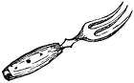
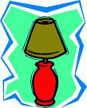
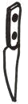
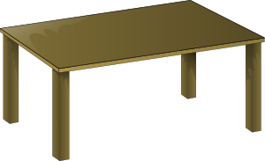
House Riddles 1
Can you find out what I am?
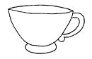
I am made of wood.
I have four legs.
You can sit on me.
I’m often in the kitchen.
You can see through me.
I’m often wet.
You pick me up.
You can use me to drink.
I’m usually round.
I have two hands.
I hang on the wall.
I can tell you the time.
I’m soft.
I’m in the living-room.
You can relax in me.
3 or 4 people can sit in me.
I’m often made of wood.
I have four legs.
You eat on me.
You put a cloth on me.

You can pick me up.
You use me to call people.
I ring.
You can speak and listen to me.

I’m in the bathroom.
I spray water.
You take or have me.
I hope you use me often.
I am made of metal.
You eat steak with me.
I am sharp.
You use me to cut.
I am a room.
I have a sink.
I have a stove.
You use me for cooking.
I can be in the bathroom.
You often sit on me.
I have water in me.
You use me often.
I have one ear.
I’m made of ceramic.
You put hot stuff in me.
You drink coffee or tea in me.

I’m in the bedroom.
I’m soft.
I have a mattress.
You use me at night.
I’m made of metal.
I often see your teeth.
I’m oval.
You eat soup with me.
I’m often made of wood.
I have a knob or handle.
You can open me.
You walk through me.
I stand on a table.
Or hang on the wall.
Or stand on the floor.
I give light.
I need electricity.
I have a screen.
I can send email.
You can play games on me.
I have teeth.
I’m made of metal.
You use me to eat.
You pick up food with me.
I am made of glass.
I hang on the wall.
You often look at me.
You can see yourself in me.
I’m in the living-room.
You can sit in me.
I am soft.
I have arms.
I’m in the living-room.
I’m boxy or flat.
You can watch me.
You use me in your free time.

I’m in the kitchen.
I’m usually white.
I’m cold.
I have food and drink in me.


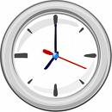


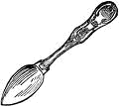
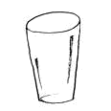
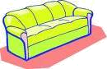


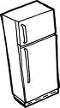
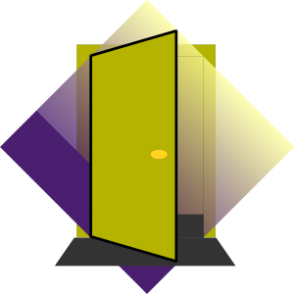
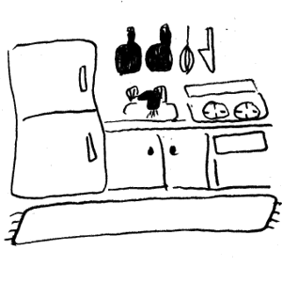
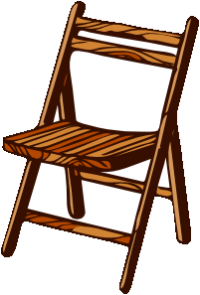
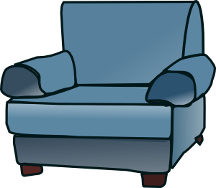
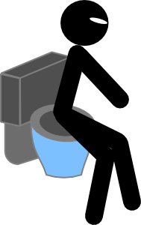
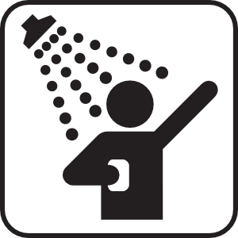
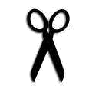
Don’t show this to other teams!
Give an extra clue if needed.
Don’t show this to other teams!
Give an extra clue if needed.
Don’t show this to other teams!
Give an extra clue if needed.
I am made of wood.
I have four legs.
You can sit on me.
I’m often in the kitchen.
You can see through me.
I’m often wet.
You pick me up.
You can use me to drink.
I’m usually round.
I have two hands.
I hang on the wall.
I can tell you the time.
I’m soft.
I’m in the living-room.
You can relax in me.
3 or 4 people can sit in me.
I’m often made of wood.
I have four legs.
You eat on me.
You put a cloth on me.

You can pick me up.
You use me to call people.
I ring.
You can speak and listen to me.

I’m in the bathroom.
I spray water.
You take or have me.
I hope you use me often.
I am made of metal.
You eat steak with me.
I am sharp.
You use me to cut.
I am a room.
I have a sink.
I have a stove.
You use me for cooking.
I’m often in the bathroom.
You often sit on me.
I have water in me.
You use me often.
I have one ear.
I’m made of ceramic or plastic.
You put hot stuff in me.
You drink coffee or tea in me.

I’m in the bedroom.
I’m soft.
I have a mattress.
You use me at night.
I’m made of metal.
I often see your teeth.
I’m oval.
You eat soup with me.
I’m often made of wood.
I have a knob or handle.
You can open me.
You walk through me.
I stand on a table.
Or hang on the wall.
Or stand on the floor.
I give light.
I need electricity.
I have a screen.
I can send email.
You can play games on me.
I have teeth.
I’m made of metal.
You use me to eat.
You pick up food with me.

I am made of glass.
I hang on the wall.
You often look at me.
You can see yourself in me.
I’m in the living-room.
You can sit in me.
I am soft.
I have arms.
I’m in the living-room.
I’m boxy or flat.
You can watch me.
You use me in your free time.

I’m in the kitchen.
I’m usually white.
I’m cold.
I have food and drink in me.
Team 1
Team 3
Team 2

Answer Key & Instructions Team Game

- The first page can be used as an individual worksheet (reading and writing focus). Help with spelling or vocabulary if necessary.
- The second page can be used as a competitive team game (reading, speaking, pronunciation and listening focus).
  - Divide the class into 2 or 3 teams.
  - One team reads out the clues slowly and clearly - one by one - on one of their cards. Don’t let teams show each other their cards.
  - Other teams listen and try to guess the animal. ONLY ONE GUESS IS ALLOWED, so teams have to work together and not guess too quickly.
  - If all the clues are exhausted, teams could show the pictures or give extra clues.
  - Teams score one point per correct answer.
  - These rules can be adapted or used creatively. Enjoy.
- After the game, students can choose an animal and write their own clue cards.
chair
glass
clock
sofa
table
(tele)phone
shower
knife
kitchen
toilet
cup
bed
spoon
door
lamp
computer
fork
mirror
armchair
TV
television
fridge

