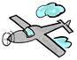

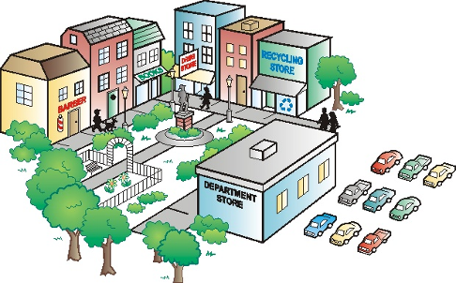

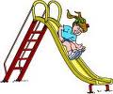

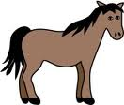



With the prepositions in the box below, make sentences like the following examples:

I can see a …… I can see a barbershop near the park.
There is/are ….. There are trees by the park.
The .…is/are …. The bench is inside the park.
Prepositions
above behind below
beside between by
In inside near
the middle of over on
next to under among

Word Bank
department store flower bushes cars tree bookshop bench grass statute horse streetlamp drugstore airplane apartment recycling store kite pond clouds people sidewalk water slide

In this town, I can see a ……………………………………….……… beside the ………………………………… .
There are / is a …………………………………………… behind the ………………………………………………… .
The ……..……………………..……..….. is / are …………………………………………. the department store.

Now you continue:
In this town, ………………………………………………………………………………………………………………………………
……………………………………………………………………………………………………………………………………………………….
……………………………………………………………………………………………………………………………………………………….
……………………………………………………………………………………………………………………………………………………….
……………………………………………………………………………………………………………………………………………………….
……………………………………………………………………………………………………………………………………………………….

