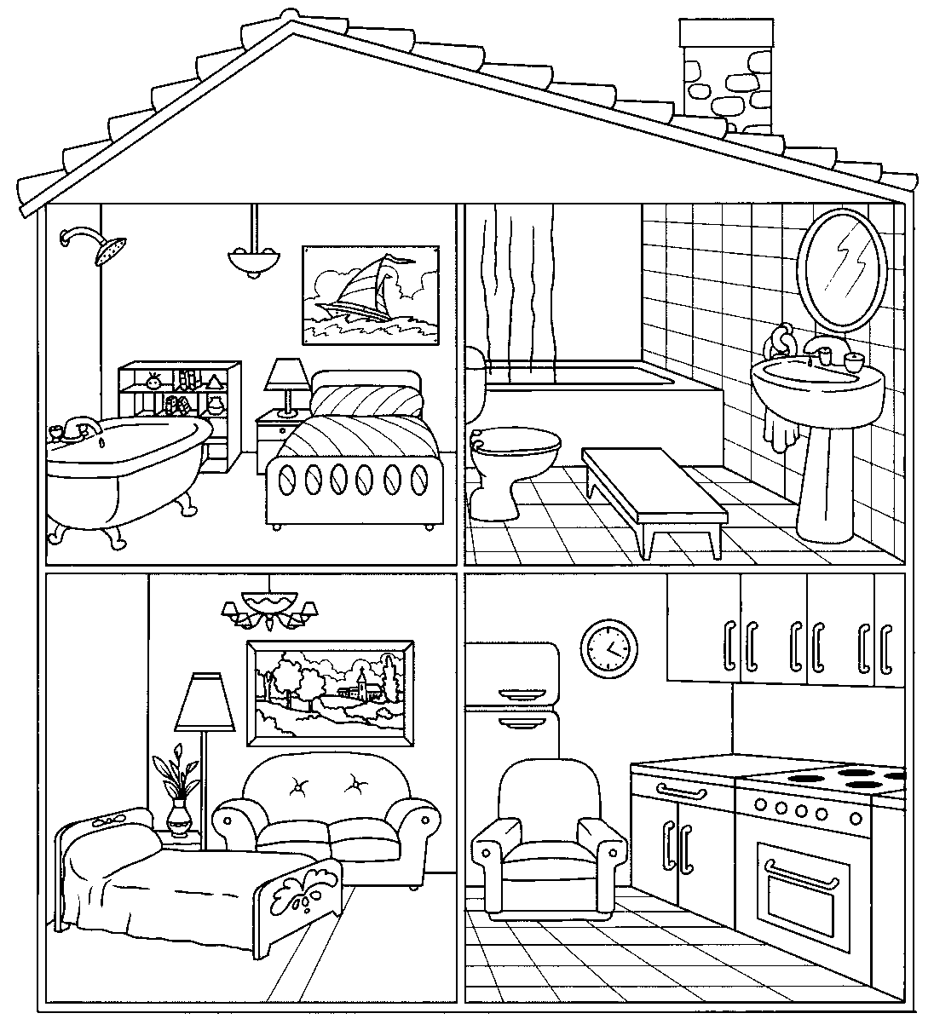
MATCH THE FURNITURE AND THE OBJECTS:
____This is a bathtub ______ This is a shower _______This is a mirror
____This is a bed ______ This is a stove _______This is a cabinet
____This is a fridge ______ This is a table _______This is a picture
____This is a lamp ______ This is a toilet _______This is a sink
____This is a curtain ______ This is a sofa
1
51
112019
3
91
1351019
12411019
143019
71
1019
43
81
21
61

