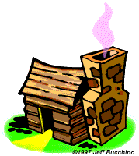
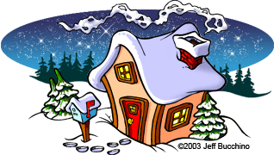
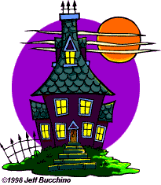
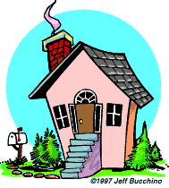
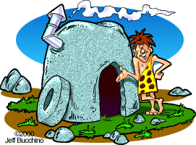
My House
Hi, I’m Freddie, I’m 17 and this is my house. I live here with my family: my parents, my sister and our dog Cuddle. Our house has got one bedroom, a small kitchen and a tiny bathroom. We don’t have electricity, but we do have running water from the river nearby. In the evening we talk and go to bed with the chickens. Bye for now. I need to go hunting for dinner.
Read the text.
Discuss: Would you like to live in a house like this? Why (not)?
Vocabulary: Guess the meaning; then check your answer.
- Tiny: ………………………………………………………………………………………………………
- Running water: ………………………………………………………………………………………
- Go to bed with the chickens: …………………………………………………………
- To hunt: …………………………………………………………………………………………………
……………………………………………………………………
- ………………………………………………………………………

Where would you want to live?
- In the city or countryside?
- Near the sea or in the mountains?
- In a house or an apartment?
- In a hot or a cold country?
- In which country? ………………………………………
Compare with others. Explain your choices.
Interview a friend; report to the class:
- (where/live)
- (house or apartment; big or small)
- (how many/rooms)
- (how far)
- (you/like)

- House
- …………………………………………………………………
- …………………………………………………………………
- …………………………………………………………………
- …………………………………………………………………
- …………………………………………………………………
- …………………………………………………………………

- …………………………………………………………………

- …………………………………………………………………

How many kinds of houses do you know? Brainstorm. Make a list.
Describe your dream house. Tell the class.
(location, number of rooms, inside/outside, extras, etc.)
My dream house …………………………………………………………………………………………
…………………………………………………………………………………………………………………………
…………………………………………………………………………………………………………………………
…………………………………………………………………………………………………………………………
…………………………………………………………………………………………………………………………
…………………………………………………………………………………………………………………………
…………………………………………………………………………………………………………………………
…………………………………………………………………………………………………………………………
…………………………………………………………………………………………………………………………
…………………………………………………………………………………………………………………………

Answer key
Vocabulary: Guess the meaning; then check your answer.
Tiny: very small, extremely small
Running water: water supplied to a house by pipes
Go to bed with the chickens: to go to bed at sundown - at the same time that chickens go to sleep
To hunt: to chase and try to kill for food, sport or profit
……………………………………………………………………
- ………………………………………………………………………

Interview a friend; report to the class:
- Where do you live?
- Do you live in a house or an apartment? Is it big or small?
- How many rooms are there (in your house)?
- How far is it from here?
- Do you like your house? Dou you like living there?

- House
- Semi-detached house
- Detached house
- Bungalow
- Villa, mansion
- Terraced house (or townhouse)
- Apartment (or flat)
- Studio
- (Log) cabin
- Hut
- House boat
- Castle, palace
- Igloo
- Tent
- Cave
Describe your dream house. Tell the class.
(location, number of rooms, inside/outside, extras, etc.)
SAMPLE: My dream house is a big house in the mountains. It has a big living-room with a home theatre for watching movies and playing video games. There is also an enormous garden with a swimming pool and lots of flowers and plants. I like nature and the outdoors. There are many bedrooms so all my friends can visit me and stay over. There is also a stable with horses so we can go horse-riding in the mountains. It has solar panels on the roof to provide electricity and an electric car to shopping in the nearby town. (Answers may vary according to student’s level)

