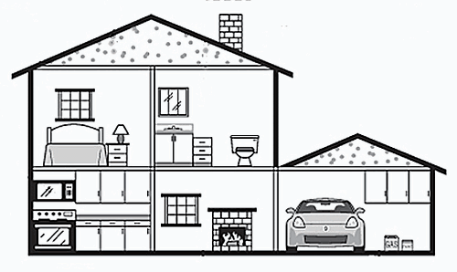
MATCH THE FURNITURE AND THE OBJECTS:

_____This is a fireplace
_____This is a microwave
_____This is a bed
_____This is a lamp
_____This is a toilet
_____This are kitchen cabinets

THE HOUSE
10100
2
6
12
3
7
9
8
11
_____This is a sink
_____This is a window
_____This is the garage
_____This is a chimney
_____This is a nigh table
_____This is the roof

4
5
1
13
143

