Name:

Class:

1.

2.

3.

1.

2.

3.

Write down what daily activities you don’t like to do daily.

Write down what daily activities you like to do daily.

How do you get to school? What time?

What does your morning look like?   
  
What time do you get up?

What time do you eat breakfast? What do you eat?

What other things do you do?

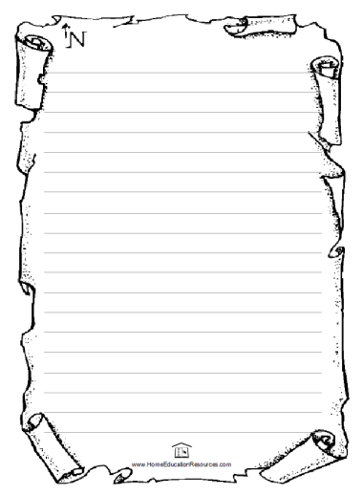

Take your classmates document and write a small story about his/her daily routine