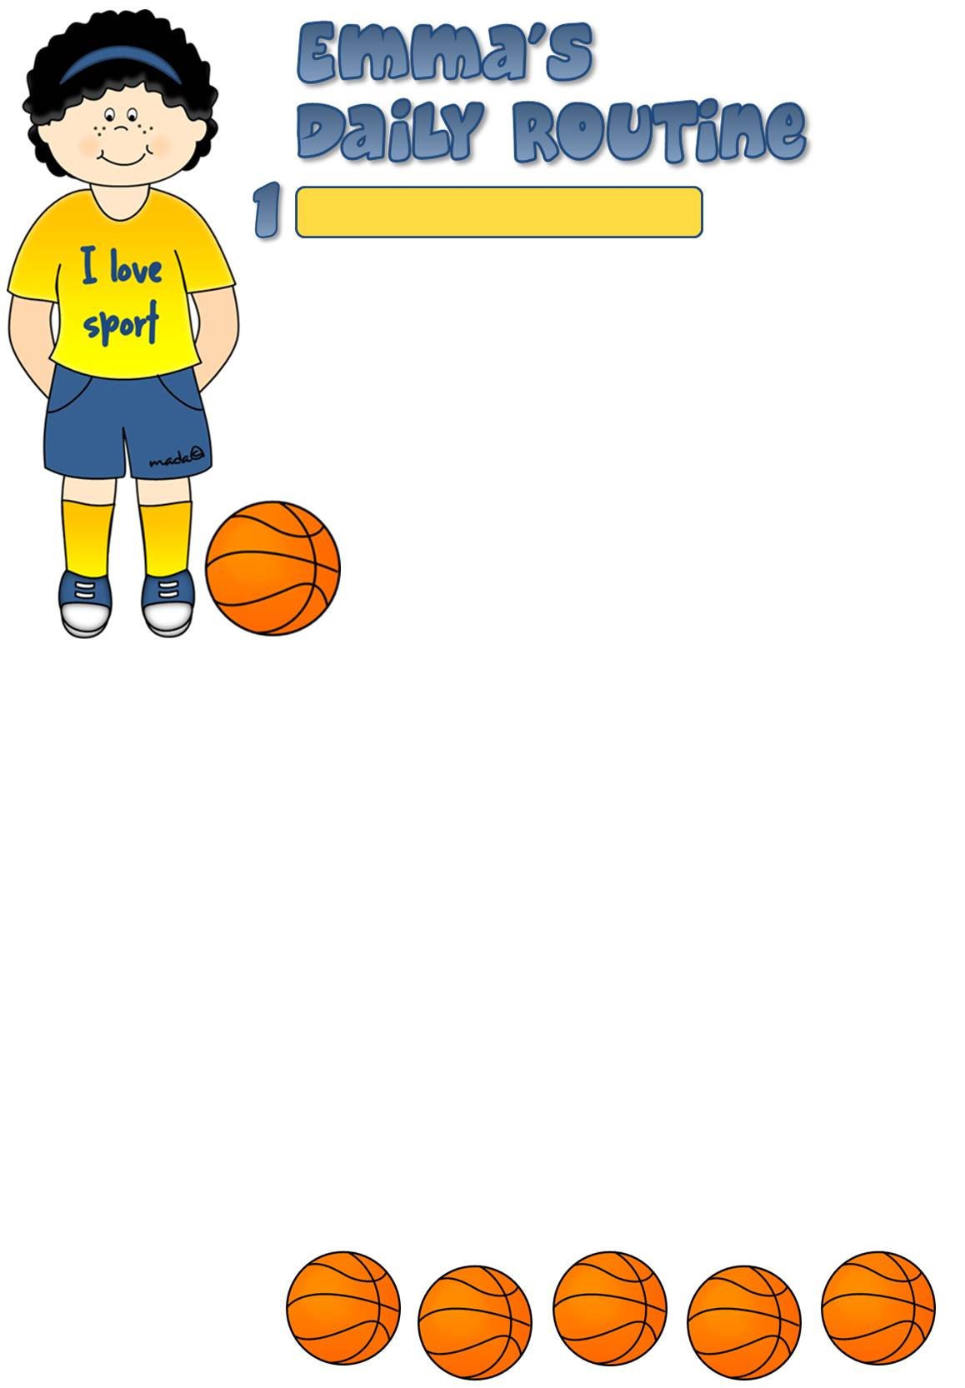
Hi! My name is Emma. I’m ten years old and I’m English. I live with my family in Brighton in the south of England.
My day usually starts quite early. I always get up at 7.30 on weekdays, but at the weekends I sleep an hour and a half longer. When I get up, I go to the bathroom first. I wash my face to wake me up, brush my teeth and then I have a shower. After
that I comb my hair and get dressed. I usually wear casual
clothes, mainly jeans, shorts, T-shirts and trainers.
I always have breakfast with my mum and my little
brother, Tommy. My dad never has breakfast with us

because he starts work early on weekdays. I usually have a bowl of cornflakes with hot milk and toast with marmalade. Before I go to school, I have to walk our dog, Leo.
I usually walk to school because I don’t live very far. Classes start at 8.30. I like Maths best but I’m also good at Science and English. I have two breaks, at 11 and at 1 o’clock. I eat a sandwich and drink orange juice. I also play with my classmates in the playground. School finishes at 3.30 and my dad picks me up and we come back home by car. Then we have lunch together.
After lunch I play with my brother for a while and then I do my homework and study. Twice a week I have a basketball practice. I love doing sports.
Before dinner I sometimes meet my friends or watch a TV quiz. I seldom play computer game, I simply find them boring. We have dinner at 7.30 and I often set the table. After dinner I read a book or surf the Internet for a while.
At 9.30 I go to the bathroom to have a shower, brush my teeth and put on my nightdress. Before I go to sleep I listen to music on my MP3 player because it makes me feel relaxed.

Read about Emma’s daily routine.

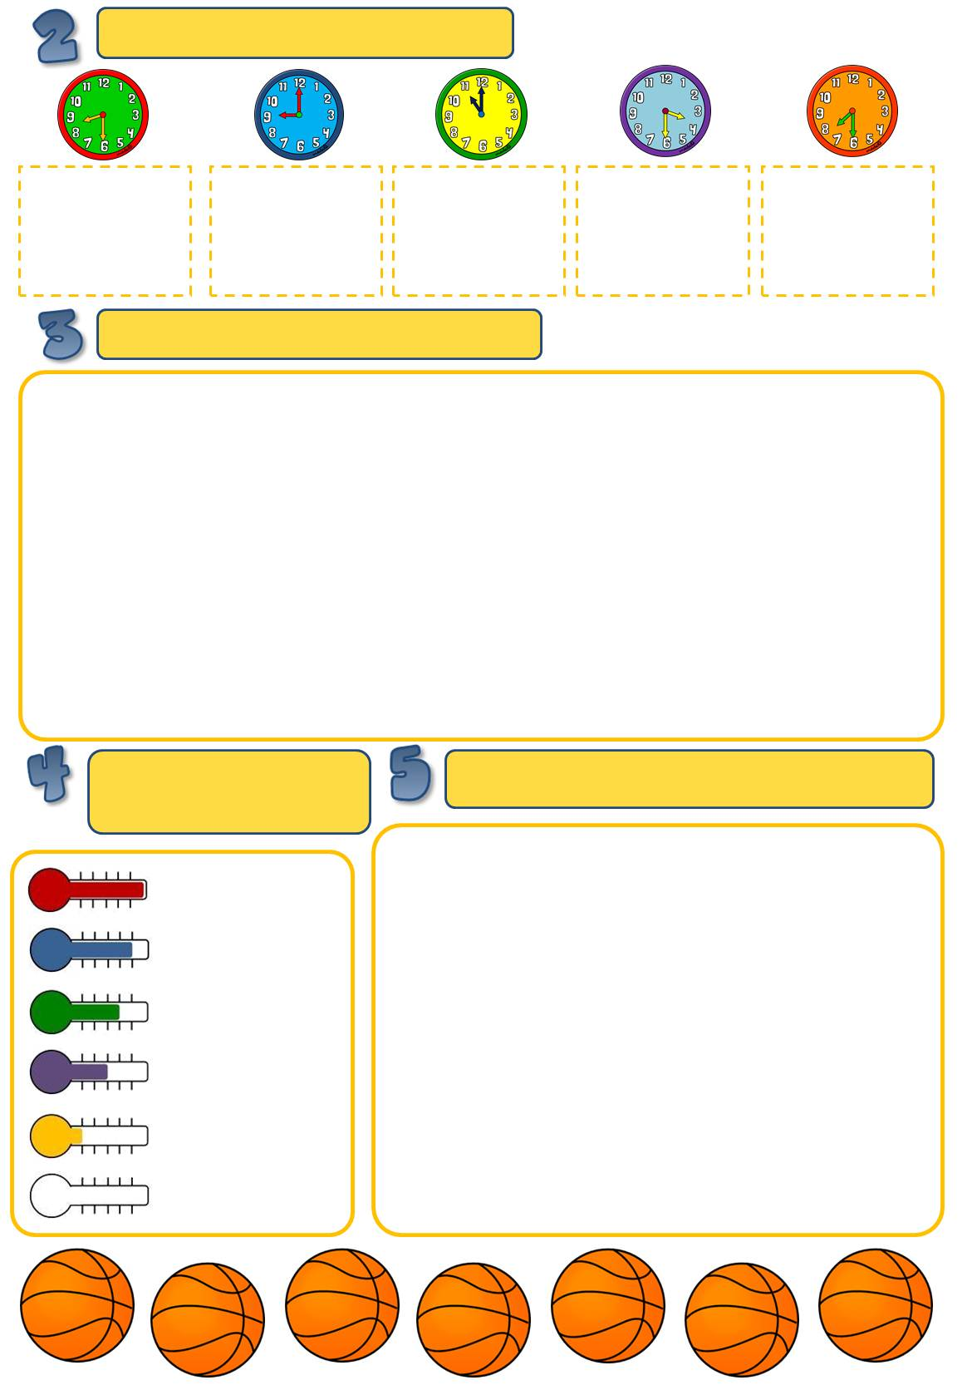
What happens at the given times?
Emma _______
_______________________.
____________
_______________________.
____________
_______________________.
____________
_______________________.
____________
_______________________.
Answer the questions about Emma.
How old is Emma?
_______________________________________
Where does she live?
_______________________________________
How many brothers and sister has she got?
_________________________________________
What kind of clothes does she like?
_________________________________________
What does she have for breakfast?
_________________________________________

How does Emma usually get to school?
_______________________________________
Where does she spend her breaks?
_______________________________________
What time do classes finish?
_________________________________________
Where does she go twice a week?
_________________________________________
What does she have for breakfast?
_________________________________________

Match the underlined
words to the symbols.
______________
______________
______________
______________
______________
______________
Put the words in order to make sentences.
for / never / I / school / late / am
_________________________________________________
have / Tuesday / Spanish / on / we
_________________________________________________
dad / work / car / often / my / to / by / goes
________________________________________________
my / I / with / always / housework / help / mum / the
________________________________________________
once / judo / week / she / a / has / classes
________________________________________________
like / very / gardening / I / much
________________________________________________

