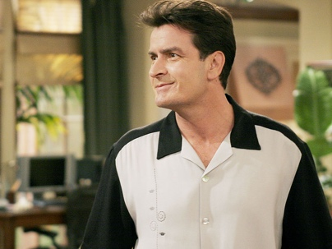<https://www.youtube.com/watch?v=aEcc_V5CTig>

Charlie

End at 3:10

**Pre-activity:**  
  
1) What do you normally wear?

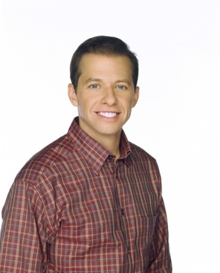

Alan

2) Do you like shopping? Why/ Why not?

3) What is your favourite item of clothing?

**While- activity:**

4) Charlie (the man in the white with black shirt) is annoyed with his brother Alan. Can you explain with multiple (meerdere) reasons?

Reason one: “This is the top floor, there is no more clothes above this floor”

Reason two: “Why don’t you pick something, PICK something”

Reason three: Why does Charlie hit his brother?

5) Which of the outfits Alan tries on do you actually like? Explain why?

6) Which of the outfits Alan tries on is the worst?

**After-activity:**

7) If you had an unlimited budget, what type of clothing would you buy?

