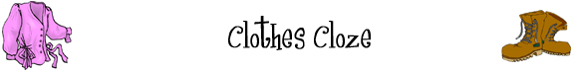
Fill in the blanks below with words from this box:
Scarf  hat  dress  for  footwear  shorts  fits  laundry |  | T-shirt  cold  wash  coat  gloves  fold  sandals | sweater  cool  boots  dry  try  sunglasses  running shoes
Winter Clothes
On a _____________ winter day, it’s important to ______________ warm. Many people wear a ________________ over their shirt. And when they go outside, they put on a warm ________________. As well, people put a ________________ on their head, __________________ on their hands, and a ________________ around their neck.

Summer Clothes
In summer, people like to keep _________________. So many people wear _________________ instead of pants and a _________________ instead of a long-sleeve shirt. As well, people wear ____________________ to protect their eyes from the bright sun.

Footwear
There are many different types of _________________. People wear __________________ to the beach, ________________ when they exercise, and _________________ on rainy or snowy days.

Shopping for Clothes
Shopping _________ clothes can be a lot fun. But before you buy anything, you should always ______________ it on and make sure it _________________.

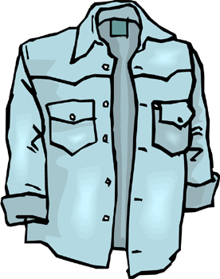 | Laundry  When your clothes get dirty, it’s time to do the ________________. First, you ________________ the clothes. Next, you _________________ them. Finally, you ___________________ them and put them away.

