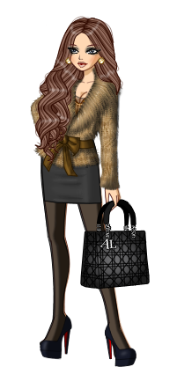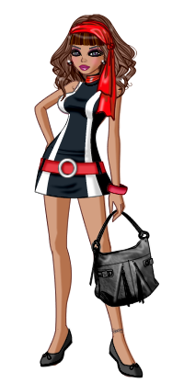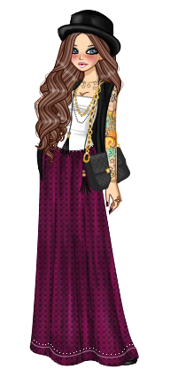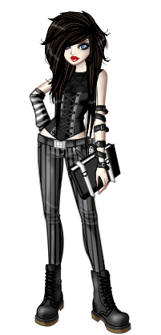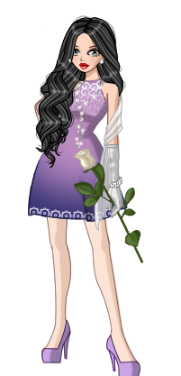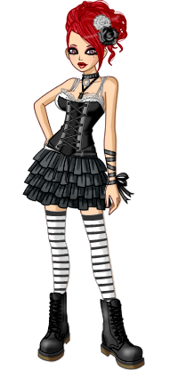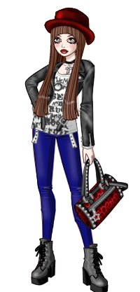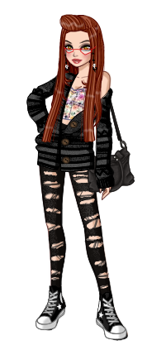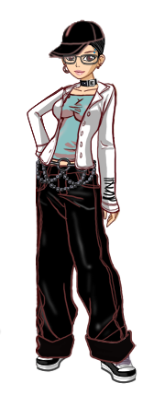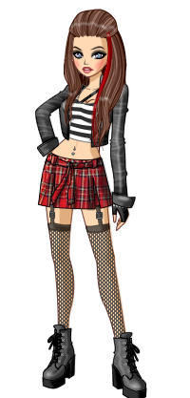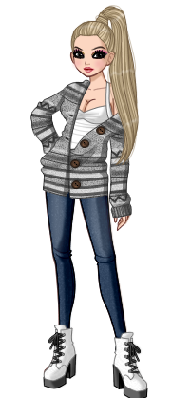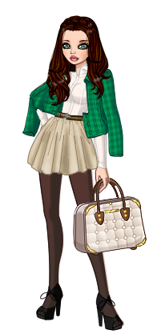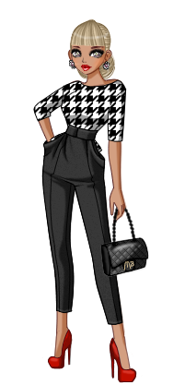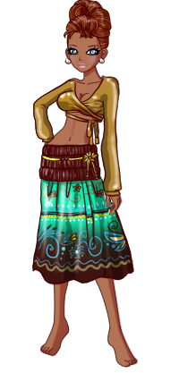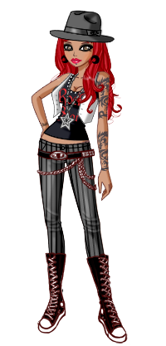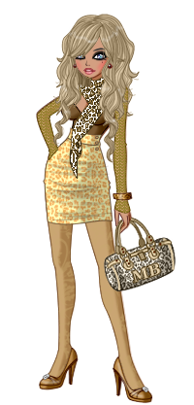

**DESCRIBING CLOTHES AND STYLE**

|  |  |  |  |
| --- | --- | --- | --- |
| **CLASSY**  Your style is elegant  and,  with clean, simple  lines, softly tailored,  not usually mix and  match.  Never trendy,  faddish or severe,  Textures such  as silk, soft woolen fabrics, cotton are among your favourites. | **funky rock**  This look  is edgy, a  fashion style  expressed by bold  hair styles and  colors, accessories,  black leather  jackets and  shirts with  funky designs. | **ETNIC**  The easiest way  to wear the look  is a print. If  prints aren’t  your thing, then  you can still  indulge in the  ethnic /tribal  fashion trend  by way of accessories. | **Girly glam**  Your outfits hug  Your body tightly  and are full of  pink, loud and  sparkly accessories,  high stilettos and  platforms. It is a  style that  exposes some of  your body and brings  out a flirty, feminine  and sexy look. |
| **BOHo chic**  It a vintage  inspired style with  earthy tones, loose  fitting clothes, and  combining certain  looks to appeal to  an eclectic vibe.  This trend is a  mix of luxurious textures and contrasting fabrics, big purses, casual, long necklaces… | **TRENDY**  You love the big city  and adore your  uniform of all black  with stiletto boots,  pumps, or sandals.  You love to dress up,  be in all the latest  trends. You know  which pieces make  the whole look appear expensive. | **PREPPY/GIRLY**  Polo shirts, or  Oxford shirts,  dresses and  T shirts all either  in pastel or bright  colors.  jeans, khakis,  slacks, or Bermuda  shorts. Oxford  shoes, tennis shoes,  ballet flats make  the look. | **CASUAL**  A cute,  sweat suit is your  go-to outfit .If an  evening activity is  on the agenda,  a quick change to  slacks or jeans and  a sweater  or nice T-shirt does  the trick. Your color  navy, gray, and black |
| **PUNK**  A lot of punk  clothing has a DIY  (do it yourself)  look to it.  Flight jackets,  skinny jeans,  leather, studs,  are the things  to wear together  with classic accessories  like, arm warmers, bullet belts, and wristbands with pyramid studs, stars or spikes. | **MOD**  Dresses and skirts  are A-line and  either mid-thigh  length or just  below the knee.  Go for crazy  patterns or stripes  with lines that pop.  Typical colors  are white and black, but you can incorporate others. Mod shoes are chunky knee- or ankle-high boots | **skater**  Their look is  more put  together and  creative then  you'd think.  Strategic  layers (long and  short sleeve  Tees) and smart,  yet  accessories  (necklaces, etc.) are  the basis of this look. | **HIPSTER**  Wear skinny jeans,  basically, the  tighter, the better.  Wear glasses and  dress vintage.  Hipster shoes  include cowboy  boots, [Converse](http://www.wikihow.com/Design-Your-Own-Converse-Sneakers),  and a range of flats.  Wearing things that don't  match together is also very hipster. |
| **HOBO**  Hobo’s clothes  must be either  painfully small or  comically large.  Hobo Shoes can  cover a wide range  of styles, as long  as they are beaten  up and battered,  fingerless gloves and hats give you the look too. | **GOTH GLAM**  Goth glam fashion  is nowa classy  version of gothic.  It still retains  dark and gloomy  colors  like black, navy  and burgundy. | **ROMANTIC**  You like to wear  soft colors and  fabrics like chiffon  and silk that drape  graciously on your  body.  You also go for  ruffle or  skirt and dresses with floral prints, lace, crocheted tops, cameos and antique jewelry. | **EMO**  Tight clothing  is still  your thing,  though much  of it has taken  a more modern  look now.  Stripes are popular  as stars, hearts,  skulls, nautical stars,  and sparrows. Hair  still black. |



**DESCRIBING CLOTHES AND STYLE**

LOOKING AT THE PICTURES ABOVE, COULD YOU DESCRIBE WHAT THE GIRLS ARE WEARING?

|  |  |  |  |  |
| --- | --- | --- | --- | --- |
|  |  |  |  |  |

**A-line**

**baggy**

**bright**

**casual**

**fashionable**

**grungy**

**large**

**leather matching**

**plaid**

**polka dot** refined

**ripped**

**Skinny sleeveless striped**

**stylish**

**tight**

**torn**

**trendy**

**well-fitting**

**belt**

**bracelet**

**earrings**

**glasses**

**handbag**

**necklace**

**purse**

**ring**

**Scarf**

**umbrella**

**wallet**

**watch**

**Cap**

**Coat**

**Dress**

**Gloves**

**Hat**

**Hoodie**

**Jacket**

**Jeans**

**Long sleeve shirt**

**Long sleeve T-shirt**

**miniskirts**

**Overalls**

**Raincoat**

**Short sleeve shirt**

**Skirt**

**Socks**

**Suit**

**Sweater / Pullover**

**Sweatshirt**

**Tights**

**TOP**

**Tracksuit**

**Trousers**

**Turtleneck**

USEFUL VOCABULARY

**boots**

**clogs**

**flip flops**

**high-heeled shoes**

**loafers**

**moccasins**,

**mules**

**platform shoes**

**sandals**

**shoes**

**slippers**

**Wellingtons**

**trainers**

**REMEMBER!!! SEQUENCE OF MULTIPLE ADJECTIVES IN CHART FORM:**

|  |  |  |  |  |  |  |  |  |  |
| --- | --- | --- | --- | --- | --- | --- | --- | --- | --- |
| **QUANTITY** | **OPINION** | **SIZE** | **AGE** | **SHAPE** | **COLOR** | **ORIGIN** | **MATERIAL** | **PURPOSE** | **NOUN** |