

READING

I’m ’interested in fashion. I enjoy reading fashion magazines and going to clothes shops, but I can’t afford to buy fashionable clothes. They’re so expensive!
I’ve got two or three special outfits that I wear when I go out, but most of the time I wear leggings and a T-shirt. My friends and I often borrow each other’s clothes. That way we can all wear something new but without spending too much money. Sheila Marple.

als

Fashion isn’t for me. I don’t care about fashion and models. I usually wear comfortable clothes, like jeans, T-shirts and sports shoes or boots in winter. Most of my friends wear the same kind of clothes. We don’t talk about famous models, music is our favourite topic of conversation.
I don’t use make-up either because I’m too young and my skin is fresh and clean. Madeleine Whooper.

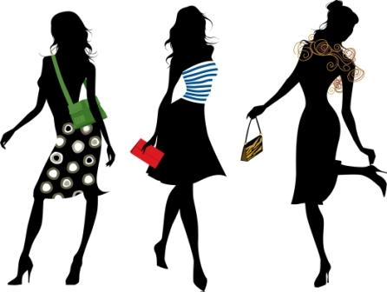
I think fashion is important because it says something about your personality. I’m a confident, outgoing person and I want my clothes to reflect this.
I hate looking boring or old-fashioned even at home! Being fashionable doesn’t have to be expensive. I sometimes buy ordinary cheap clothes and then alter them at home. I also like designing my clothes. My mother helps me a lot because she can sew very well. Marina Fellow.

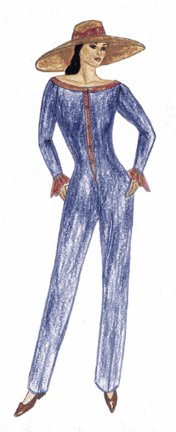
CORRECT THE MISTAKES
1.- Sheila never wears leggins. ___________________________
2.- Sheila likes reading magazines. ___________________________
3.- Sheila often borrows her friend’s clothes. _________________________
4.- Madeleine is interested in fashion. ______________________
5.- Madeleine loves music. _____________________________
6.- Marina buys expensive clothes. _____________________________
7.- Marina hates designing her clothes. _____________________________
8.- Marina’s mother can’t sew. _____________________________

