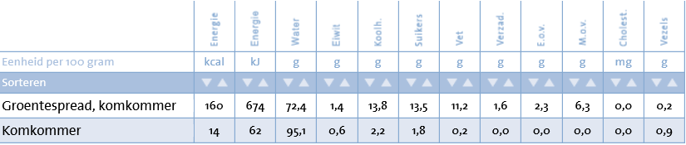 

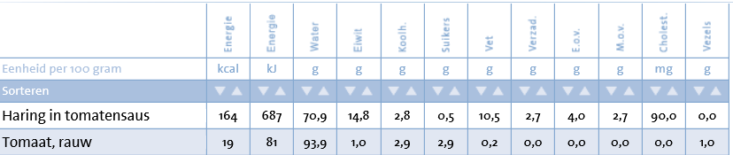 

[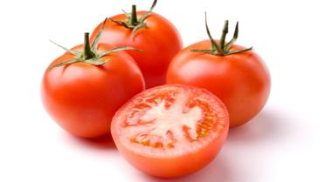](http://www.google.nl/url?sa=i&rct=j&q=&esrc=s&source=images&cd=&cad=rja&uact=8&ved=0ahUKEwi2zJr1leTQAhWD2BoKHSW-DP0QjRwIBw&url=http%3A%2F%2Fkoken.vtm.be%2Fingredienten%2Ftomaat&psig=AFQjCNE3bt2XTcO-JqRzaFlBcVtucZ7rxg&ust=1481271878112639) [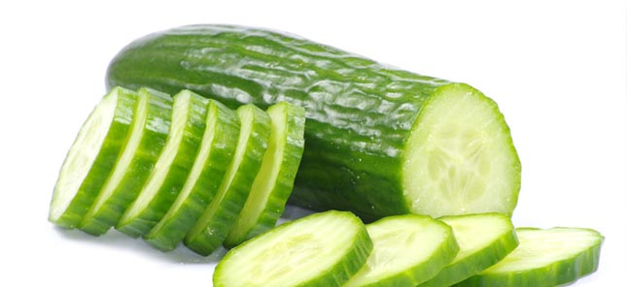](http://www.google.nl/url?sa=i&rct=j&q=&esrc=s&source=images&cd=&cad=rja&uact=8&ved=0ahUKEwjwgbKEluTQAhUEXRoKHQjjAtIQjRwIBw&url=http%3A%2F%2Fwww.ttmcommunicatie.nl%2Fnieuws%2Fkomkommertijd-6-weetjes-over-komkommers%2F&bvm=bv.140915558,d.ZGg&psig=AFQjCNGLypGaqvGGbT3YiV20esbd1SBEmw&ust=1481271912728902)