[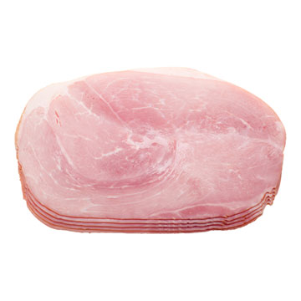](https://www.google.nl/url?sa=i&rct=j&q=&esrc=s&source=images&cd=&cad=rja&uact=8&ved=0ahUKEwiezPfyl-TQAhWFCBoKHaZ6C9QQjRwIBw&url=https%3A%2F%2Fwww.voedingswaardetabel.nl%2Fvoedingswaarde%2Fvoedingsmiddel%2F%3Fid%3D133&bvm=bv.140915558,d.ZGg&psig=AFQjCNF59nXJzEqe3b_5VtI2kDEebYn-yw&ust=1481272386488862) [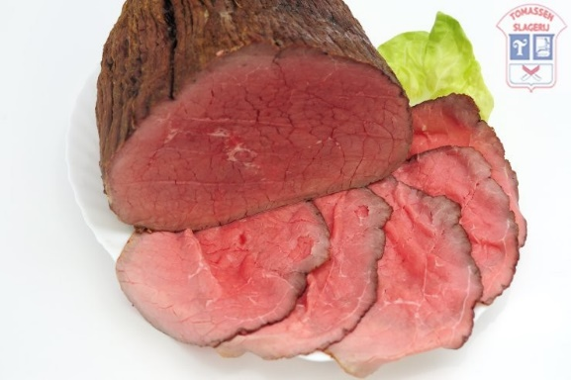](http://www.google.nl/url?sa=i&rct=j&q=&esrc=s&source=images&cd=&cad=rja&uact=8&ved=0ahUKEwj06dqq6eHQAhXIbxQKHXc5DU8QjRwIBw&url=http://www.tomassen.eu/gebraden-rosbief-1.html&bvm=bv.140496471,d.ZGg&psig=AFQjCNF4rzElAkNALqeDZH5fLy7Ai7OTpg&ust=1481191191696700)[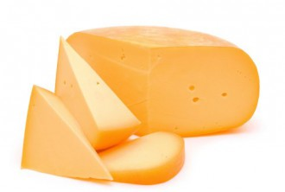](http://www.google.nl/url?sa=i&rct=j&q=&esrc=s&source=images&cd=&cad=rja&uact=8&ved=0ahUKEwjQpciM6eHQAhVFPRQKHebnCJIQjRwIBw&url=http://www.larakwant.nl/news/kaas&bvm=bv.140496471,d.ZGg&psig=AFQjCNGhilP1HtDd9V1CIMgglkp0Ybwteg&ust=1481191128185763)[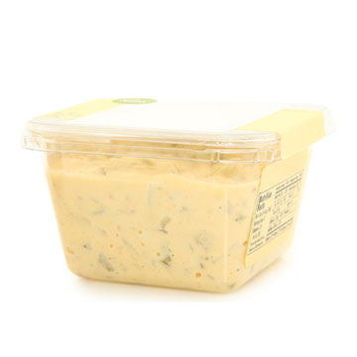](https://www.google.nl/url?sa=i&rct=j&q=&esrc=s&source=images&cd=&cad=rja&uact=8&ved=0ahUKEwjP0rWpmOTQAhUCWxoKHfbvDmkQjRwIBw&url=https%3A%2F%2Fwww.voedingswaardetabel.nl%2Fvoedingswaarde%2Fvoedingsmiddel%2F%3Fid%3D952&bvm=bv.140915558,d.ZGg&psig=AFQjCNHx4u_xUYYg_bZz_Xp_6RL_EmJSUA&ust=1481272517016132)

